AWS CERTIFIED CLOUD PRACTITIONER

PRACTICE QUESTIONS
(Week 3)
(Secondary Journey)

Reference: https://docs.aws.amazon.com/
https://tutorialsdojo.com/aws-cheat-sheets/

1. QUESTION
Category: CCP – Cloud Technology and Services
You wish to host a static website of your own in AWS at a low cost. Which service should be used for this purpose?
- Amazon S3 Infrequent Access
- Amazon EC2
- Amazon S3 Standard (Correct)
- Amazon Elastic Load Balancer

Amazon S3 provides a simple web service interface that you can use to store and retrieve any amount of data, at any time, from anywhere on the web. Using this web service, you can easily build applications that make use of Internet storage. Since Amazon S3 is highly scalable and you only pay for what you use, you can start small and grow your application as you wish, with no compromise on performance or reliability.
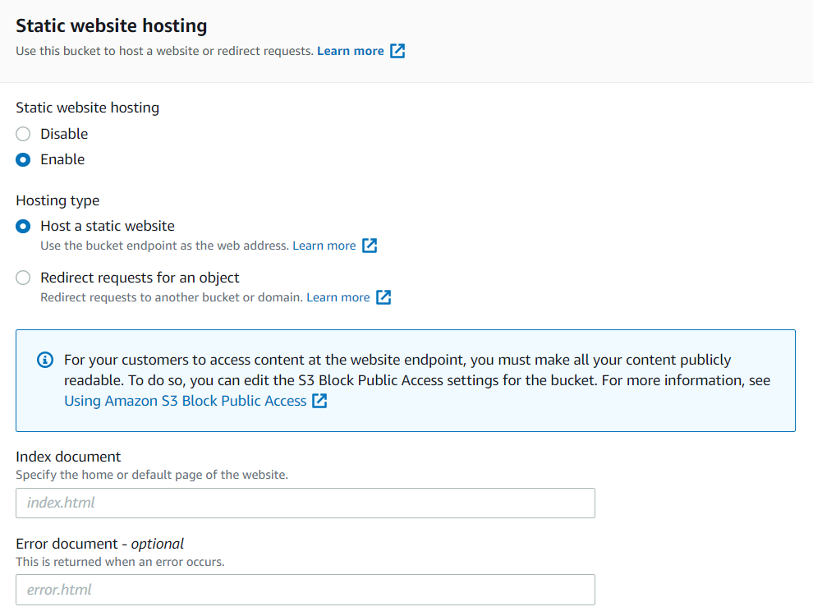
You can host a static website on Amazon Simple Storage Service (Amazon S3). On a static website, individual webpages include static content. To host a static website, you configure an Amazon S3 bucket for website hosting, and then upload your website content to the bucket. This bucket must have public read access. Amazon S3 Standard only charges you a small amount per month, which is perfect for this scenario’s needs.
Hence, the correct answer is: Amazon S3 Standard.
Amazon S3 Infrequent Access is incorrect because this may not be the storage choice for a static website. Since this is a website, you expect multiple visitors a day who will also be accessing your objects at a frequent rate. S3 infrequent access GET requests cost more than a standard S3 storage type.
Amazon EC2 is incorrect because using this will not be as cost-effective as using Amazon S3 Standard for static website hosting. This is because there are other costs to consider when using EC2 instances, such as EBS volumes.
Amazon Elastic Load Balancer is incorrect because a standalone load balancer cannot host content. You require a source for your content, such as an EC2 instance or Lambda function, and use this source in tandem with an ELB. The purpose of an ELB is to redirect incoming traffic to only your healthy instances to increase the availability of your website.

References:
https://docs.aws.amazon.com/AmazonS3/latest/dev/WebsiteHosting.html
https://docs.aws.amazon.com/AmazonS3/latest/dev/storage-class-intro.html#sc-infreq-data-access

Check out this Amazon S3 Cheat Sheet:
https://tutorialsdojo.com/amazon-s3/

S3 Standard vs S3 Standard-IA vs S3 One Zone-IA vs S3 Intelligent Tiering Comparison:
https://tutorialsdojo.com/s3-standard-vs-s3-standard-ia-vs-s3-one-zone-ia/

2. QUESTION
Category: CCP – Cloud Technology and Services
Which service in AWS is best used for data analytics and data warehousing?
- Amazon Aurora
- Amazon DynamoDB
- Amazon S3
- Amazon Redshift (Correct)
Amazon Redshift is a fast, fully managed data warehouse that makes it simple and cost-effective to analyze all your data using standard SQL and your existing Business Intelligence (BI) tools. It allows you to run complex analytic queries against petabytes of structured data, using sophisticated query optimization, columnar storage on high-performance local disks, and massively parallel query execution.
Traditional data warehouses require significant time and resource to administer, especially for large datasets. In addition, the financial cost associated with building, maintaining, and growing self-managed, on-premise data warehouses is very high. As your data grows, you have to constantly trade-off what data to load into your data warehouse and what data to archive in storage so you can manage costs, keep ETL complexity low, and deliver good performance.
Amazon Redshift not only significantly lowers the cost and operational overhead of a data warehouse, but with Redshift Spectrum, also makes it easy to analyze large amounts of data in its native format without requiring you to load the data.
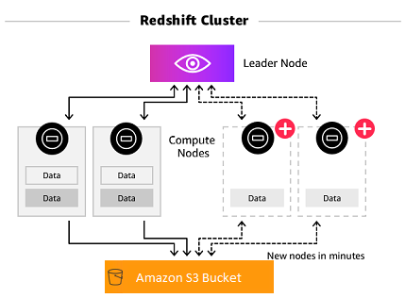
Hence, the correct answer is Amazon Redshift.
Amazon Aurora is not the optimal choice for data warehousing since it uses a traditional SQL OLTP database, which is not as fast as Amazon Redshift.
Amazon DynamoDB and Amazon S3 are incorrect because these are not the best choices for business analytics databases due to the complex queries that are being performed on large sets of data. You need a storage type that is designed for this purpose, such as Redshift.

References:
https://aws.amazon.com/redshift/
https://docs.aws.amazon.com/redshift/latest/mgmt/overview.html

3. QUESTION
Category: CCP – Cloud Technology and Services
What feature will allow you to label and sort your EC2 instances according to their deployment stage (development, staging, production)?
- Instance type
- Instance tags (Correct)
- Instance metadata
- Instance userdata

Amazon EC2 provides different resources that you can create and use. Some of these resources include images, instances, volumes, and snapshots. When you create a resource, AWS assigns the resource a unique resource ID. Some resources can be tagged with values that you define, to help you organize and identify them.
To help you manage your instances, images, and other Amazon EC2 resources, you can optionally assign your own metadata to each resource in the form of tags. Tags enable you to categorize your AWS resources in different ways, for example, by purpose, owner, or environment. This is useful when you have many resources of the same type—you can quickly identify a specific resource based on the tags you’ve assigned to it.
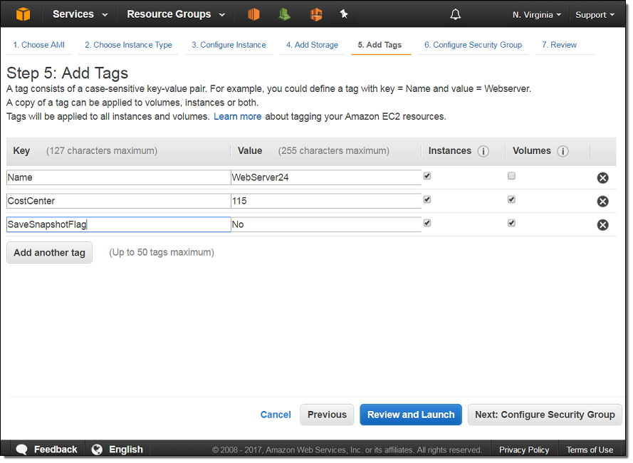
Hence, the correct answer is Instance tags.
Instance metadata is incorrect because it just details the server and network information of the instance itself. This is automatically generated for you by AWS when you launch an instance. To add metadata of your own, use tags.
Instance user data is incorrect because this is just a custom script that you prepare if you want your instance to be initialized every time it is launched. You cannot add metadata such as environment tags here.
Instance type is incorrect because this is not modifiable and cannot contain user-provided metadata. These are already fixed values provided to you by AWS.

References:
https://docs.aws.amazon.com/AWSEC2/latest/UserGuide/Using_Tags.html
https://aws.amazon.com/answers/account-management/aws-tagging-strategies/

4. QUESTION
Category: CCP – Cloud Technology and Services
Which of the following options allows customers to find, buy, and immediately start using the software and services that run on AWS?
- AWS Marketplace (Correct)
- Reserved Instance Marketplace
- AWS IQ
- AWS Partner Network

The AWS Marketplace enables qualified partners to market and sells their software to AWS Customers. AWS Marketplace is an online software store that helps customers find, buy, and immediately start using the software and services that run on AWS.
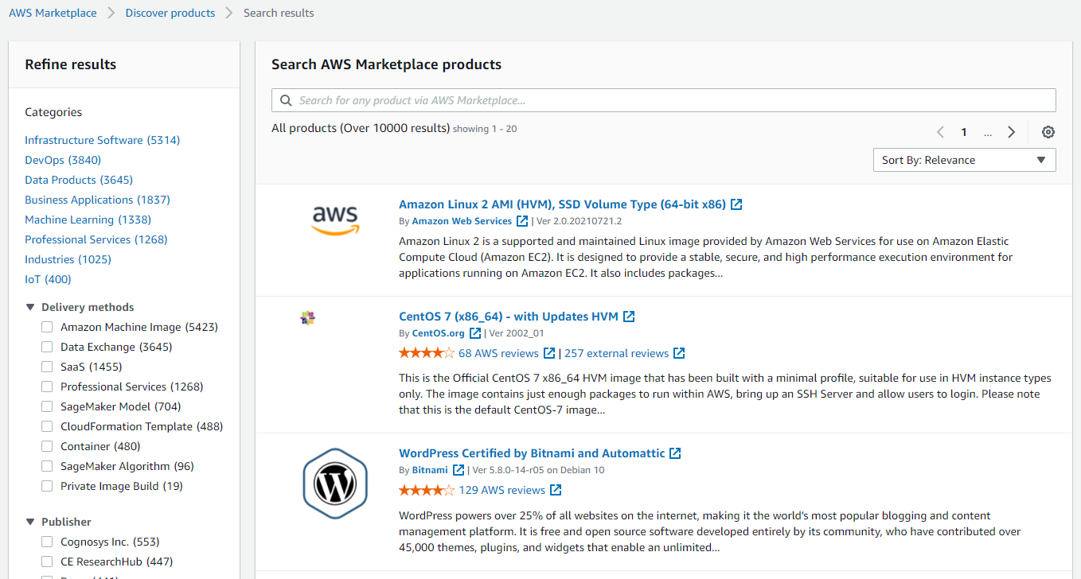
AWS Marketplace is designed for Independent Software Vendors (ISVs), Value-Added Resellers (VARs), and Systems Integrators (SIs) who have software products they want to offer to customers in the cloud. Partners use AWS Marketplace to be up and running in days and offer their software products to customers around the world.
Hence, the correct answer is AWS Marketplace.
AWS IQ is incorrect because this enables customers to quickly find, engage, and pay AWS Certified third-party experts for on-demand project work.
Reserved Instance Marketplace is incorrect because this is a platform that supports the sale of third-party and AWS customers’ unused Standard Reserved Instances, which vary in term lengths and pricing options. For example, you may want to sell Reserved Instances after moving instances to a new AWS Region, changing to a new instance type, ending projects before the term expiration, when your business needs change, or if you have unneeded capacity.
AWS Partner Network is incorrect because this is just a global community of partners that leverages programs, expertise, and resources to build, market, and sell customer offerings. The AWS Marketplace is the right website to look for software and services that run on AWS.

References:
https://aws.amazon.com/partners/aws-marketplace/
https://aws.amazon.com/marketplace/
https://aws.amazon.com/marketplace/help

Check out these AWS Overview Cheat Sheets:
https://tutorialsdojo.com/aws-cheat-sheets-overview/

5. QUESTION
Category: CCP – Cloud Technology and Services
Which service in AWS supports various business intelligence tools such as Apache Spark so that you may perform data transformation workloads (ETL) and analytics at a low cost?
- Amazon OpenSearch
- Amazon RDS
- Amazon Redshift
- Amazon EMR (Correct)

Amazon EMR is a web service that enables businesses, researchers, data analysts, and developers to easily and cost-effectively process vast amounts of data. It utilizes a hosted Apache Hadoop framework running on the web-scale infrastructure of Amazon EC2 and Amazon S3. Amazon EMR lets you focus on crunching or analyzing your data without having to worry about time-consuming set-up, management, or tuning of Hadoop clusters or the compute capacity upon which they sit.
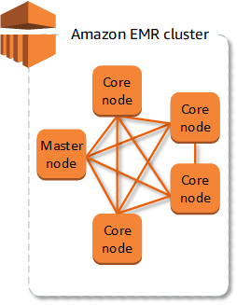
Customers across many industry verticals use EMR to securely and reliably handle broad sets of big data use cases, including machine learning, data transformations (ETL), financial and scientific simulation, bioinformatics, log analysis, and deep learning. EMR gives teams the flexibility to run use cases on single-purpose short-lived clusters that automatically scale to meet demand, or on long-running highly available clusters using the new multi-master deployment mode.
Hence, the correct answer is Amazon EMR.
Amazon OpenSearch, Amazon Redshift, and Amazon RDS are incorrect because all of these are different types of databases and search engines. They do not support Apache business intelligence tools and you cannot perform ETL jobs using these tools alone.

References:
https://aws.amazon.com/emr/
https://docs.aws.amazon.com/emr/latest/ManagementGuide/emr-what-is-emr.html

Check out this Amazon EMR Cheat Sheet:
https://tutorialsdojo.com/amazon-emr/

6. QUESTION
Category: CCP – Cloud Technology and Services
A Software Developer is working on an application for a startup. The company wants to incorporate a conversational interface that allows customers to interact with the app through voice and text.
Which of the following AWS service would help the developer to build the application?
- Amazon Personalize
- Amazon Translate
- Amazon Lex (Correct)
- Amazon Polly

Amazon Lex is a powerful artificial intelligence service enabling developers to build conversational application interfaces. With Amazon Lex, developers can quickly create intelligent bots that can understand natural language input and respond to user requests in a human-like manner. The service uses advanced natural language processing and machine learning algorithms to interpret user input and generate appropriate responses.
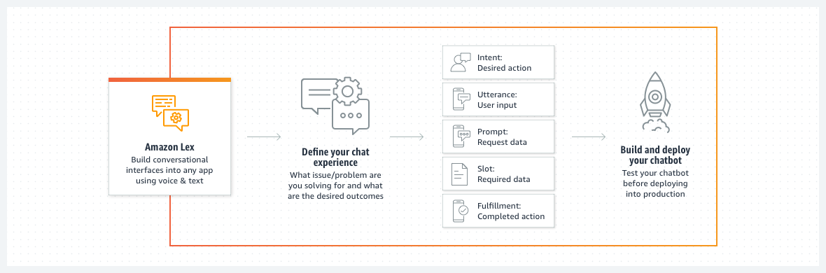
One of the key benefits of Amazon Lex is its ease of use. The service provides a simple-to-use console that lets developers quickly configure and deploy their bots. Developers can use the console to specify the bot’s intents, sample utterances, and slot types. Furthermore, Amazon Lex integrates seamlessly with other Amazon services, such as AWS Lambda, Amazon DynamoDB, and Amazon S3, enabling developers to build robust, data-driven bots that can perform complex tasks.
Hence the correct answer to the given scenario is: Amazon Lex.
Amazon Personalize is incorrect because this service only focuses on providing personalized recommendations for users based on their preferences and behavior. Moreover, Amazon Personalize does not provide the necessary components for understanding and conversationally responding to user inputs.
Amazon Translate is incorrect because the primary purpose of this service is only for translating text between languages. It does not provide the core functionality required to build the conversational interface.
Amazon Polly is incorrect because it just converts text into lifelike speech. It provides a text-to-speech (TTS) functionality, allowing applications to generate spoken output from text inputs. However, this service does not provide the natural language understanding and dialog management capabilities essential for building a conversational interface.

References:
https://aws.amazon.com/lex
https://docs.aws.amazon.com/lexv2/latest/dg/how-it-works.html

Check out these Amazon Lex Cheat Sheets:
https://tutorialsdojo.com/amazon-lex/
7. QUESTION
Category: CCP – Cloud Technology and Services
Which of the following services allows you to purchase Reserved Instances? (Select TWO.)
- Amazon EKS
- AWS Elastic Beanstalk
- AWS Batch
- Amazon EC2 (Correct)
- Amazon RDS (Correct)

Reserved Instances provide you with a significant discount compared to On-Demand instance pricing. In addition, when Reserved Instances are assigned to a specific Availability Zone, they provide a capacity reservation, giving you additional confidence in your ability to launch instances when you need them.
Standard Reserved Instances (RI) provide you with a significant discount compared to On-Demand instance pricing and can be purchased for a 1-year or 3-year term. The average discount off On-Demand instances varies based on your term and chosen payment options. Customers have the flexibility to change the Availability Zone, the instance size, and networking type of their Standard Reserved Instances.
Convertible Reserved Instances (RI) provide you with a significant discount compared to On-Demand Instances and can be purchased for a 1-year or 3-year term. Purchase Convertible Reserved Instances if you need additional flexibility, such as the ability to use different instance families, operating systems, or tenancies over the Reserved Instance term.
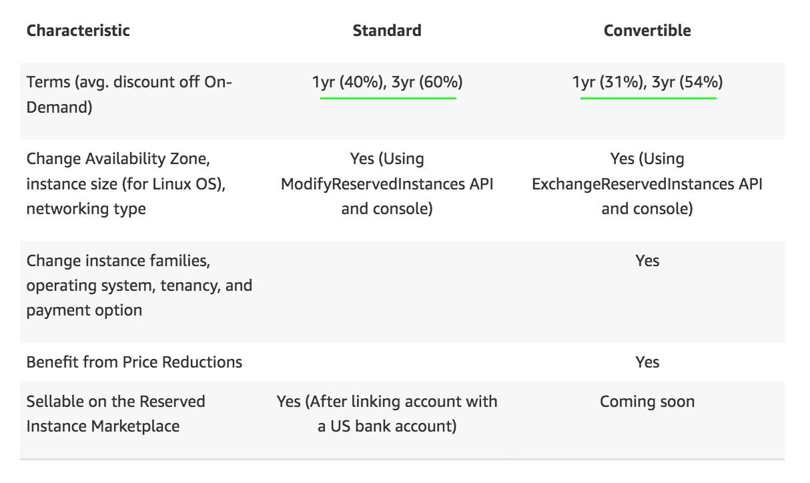
For stable applications, your organization can achieve significant cost savings by using Amazon EC2 Reserved Instances. Amazon EC2 Reserved Instances enable you to commit to usage parameters at the time of purchase to achieve a lower hourly rate.
Reservation models are also available for Amazon Relational Database Service (Amazon RDS), Amazon ElastiCache, Amazon Redshift, and Amazon DynamoDB.
Hence, the correct answers are Amazon EC2 and RDS.
All other options are incorrect because AWS Batch, AWS Elastic Beanstalk and Amazon EKS do not have reservation models of their own.
References:
https://docs.aws.amazon.com/whitepapers/latest/cost-optimization-reservation-models/introduction.html
https://aws.amazon.com/ec2/pricing/reserved-instances/pricing/
Check out this Amazon EC2 Cheat Sheet:
https://tutorialsdojo.com/amazon-elastic-compute-cloud-amazon-ec2/

8. QUESTION
Category: CCP – Cloud Technology and Services
A company has multiple AWS accounts. How can they take advantage of this to save on their monthly costs?
- Use AWS Organizations and enable consolidated billing (Correct)
- Migrate all resources to a central account to take advantage of volume discounts
- Create an IAM Group containing all the AWS accounts and enable consolidated billing
- Set a budget for each account to minimize spending

AWS Organizations is an account management service that enables you to consolidate multiple AWS accounts into an organization that you create and centrally manage. AWS Organizations includes account management and consolidated billing capabilities that enable you to better meet the budgetary, security, and compliance needs of your business. As an administrator of an organization, you can create accounts in your organization and invite existing accounts to join the organization.
You can use the consolidated billing feature in AWS Organizations to consolidate billing and payment for multiple AWS accounts. You can combine the usage across all accounts in the organization to share the volume pricing discounts and Reserved Instance discounts. This can result in a lower charge for your project, department, or company than with individual standalone accounts.
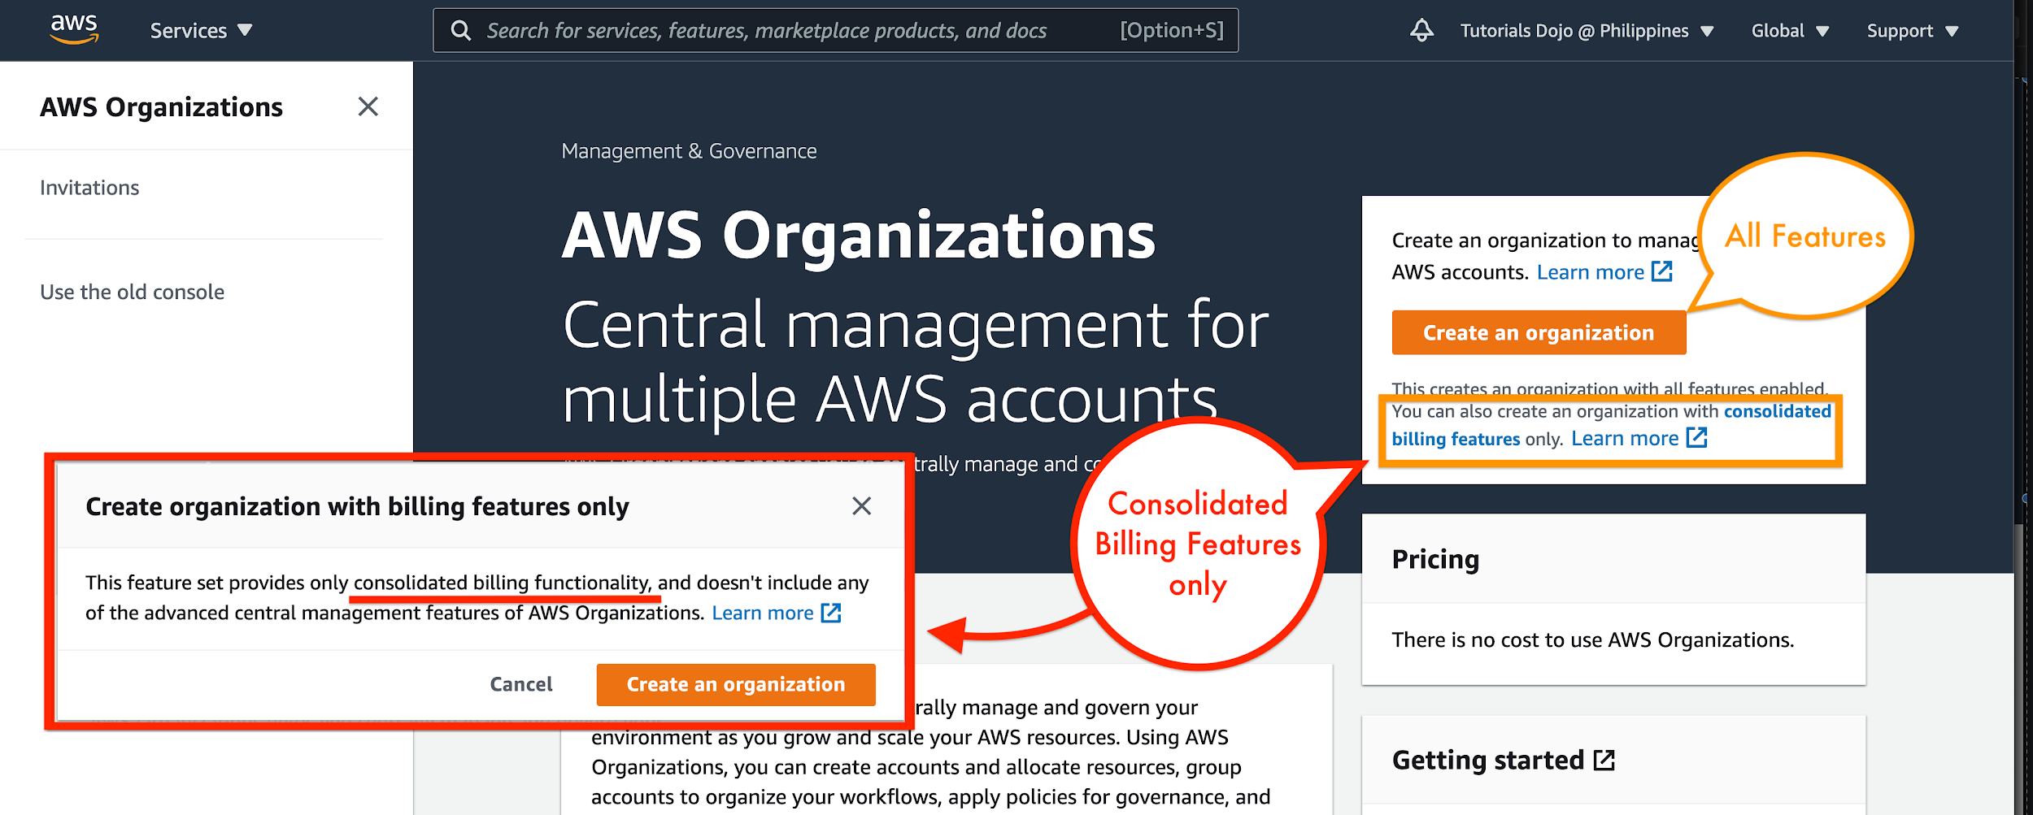
Hence, the correct answer is: Use AWS Organizations and enable consolidated billing.
The option that says: Create an IAM Group containing all the AWS accounts and enable consolidated billing is incorrect because IAM Groups are used for IAM Users. It is not intended to be used with other AWS accounts.
The option that says: Migrate all resources to a central account to take advantage of volume discounts is incorrect because migrating your applications would take too much time, effort, and resources to pull off. You can easily combine your AWS accounts through AWS Organizations and lessen the work that needed to be done.
The option that says: Set a budget for each account to minimize spending is incorrect. Although setting a maximum budget for each account is an acceptable practice, you still cannot gain significant cost reductions in your billing. It is better to use AWS Organizations and enable Consolidated Billing instead to take advantage of volume discounts.

References:
https://docs.aws.amazon.com/organizations/latest/userguide/orgs_introduction.html
https://docs.aws.amazon.com/awsaccountbilling/latest/aboutv2/consolidated-billing.html
https://docs.aws.amazon.com/awsaccountbilling/latest/aboutv2/useconsolidatedbilling-discounts.html

Check out this AWS Organizations Cheat Sheet:
https://tutorialsdojo.com/aws-organizations/

9. QUESTION
Category: CCP – Cloud Concepts
Your organization would like to boost productivity by improving business communication channels and customer service experience. Which of the following AWS applications would you suggest? (Select TWO.)
- AWS Marketplace
- Amazon Connect (Correct)
- Amazon Chime (Correct)
- AWS Transfer Family
- Amazon Workspaces
Amazon Chime is a high-quality communications service that transforms online meetings with an easy-to-use app that works seamlessly across all your devices. With Amazon Chime, you can schedule and attend online meetings and video conferences, and chat, call, and collaborate, inside and outside your organization, all with a single app. Now you can work productively from wherever you are. Amazon Chime is also integrated with Microsoft Outlook Calendar and Google Calendar for easy scheduling of meetings.
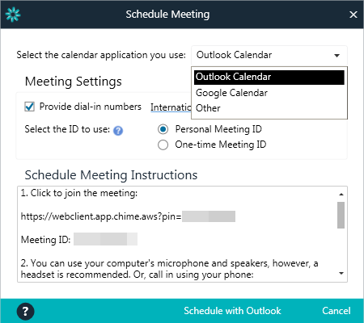
Amazon Connect is an easy-to-use omnichannel cloud contact center that helps companies provide superior customer service across voice, chat, and tasks at a lower cost than traditional contact center systems. You can create different channels and integrations with other AWS services such as Amazon Lex and Amazon Polly to create multiple types of actions and responses for customers who contact you.
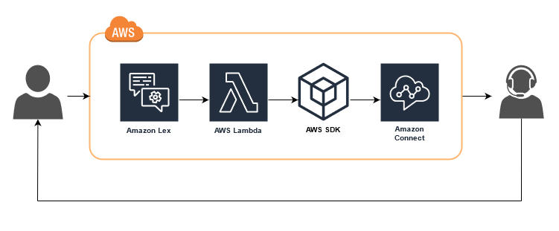
Hence, the correct answers are:
– Amazon Chime
– Amazon Connect
AWS Transfer Family is incorrect because this tool is used for recurring business-to-business file transfers to Amazon S3 and Amazon EFS using SFTP, FTPS, and FTP protocols.
AWS Marketplace is incorrect because this is a sales channel for ISVs and Consulting Partners to sell their solutions to AWS customers.
Amazon Workspaces is incorrect because this is a fully managed desktop virtualization service for Windows and Linux, and is not related to business communications or customer service.

References:
https://aws.amazon.com/connect/
https://aws.amazon.com/chime/

Check out our AWS Cheat Sheets:
https://tutorialsdojo.com/aws-cheat-sheets/

10. QUESTION
Category: CCP – Billing, Pricing and Support
Which AWS support plan includes a Concierge Support Team which will assist you with your billing and account inquiries, and work with you to implement billing and account best practices?
- Developer support plan
- Enterprise support plan (Correct)
- Business support plan
- Basic support plan

The Concierge Support Team is composed of AWS billing and account experts that specialize in working with enterprise accounts. They will quickly and efficiently assist you with your billing and account inquiries, and work with you to implement billing and account best practices so that you can focus on what matters: running your business.
AWS Support offers a range of plans that provide access to tools and expertise that support the success and operational health of your AWS solutions. All support plans provide 24×7 access to customer service, AWS documentation, whitepapers, and support forums. For technical support and more resources to plan, deploy, and improve your AWS environment, you can select a support plan that best aligns with your AWS use case.
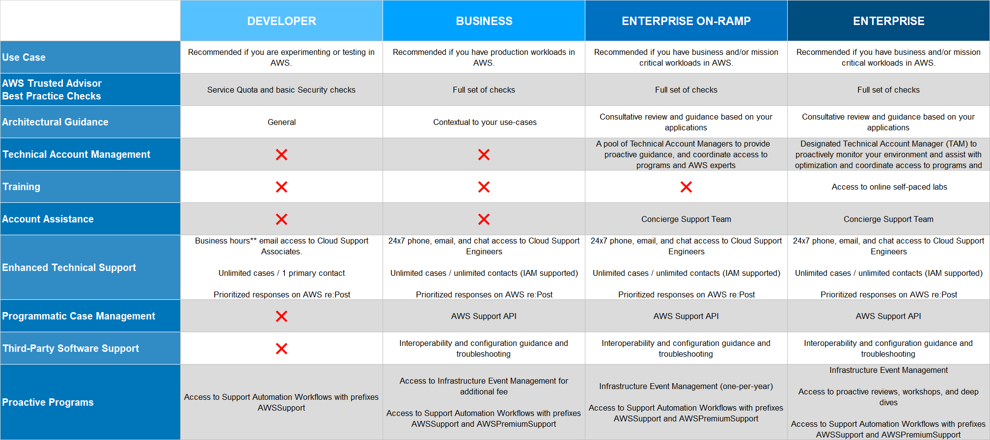
AWS Support offers five support plans: Basic, Developer, Business, Enterprise On-Ramp, and Enterprise. The Basic plan is free of charge and offers support for account and billing questions and service limit increases. The other plans offer an unlimited number of technical support cases with pay-by-the-month pricing and no long-term contracts, providing the level of support that meets your needs.
All AWS customers automatically have around-the-clock access to these features of the Basic support plan:
– Customer Service: one-on-one responses to account and billing questions
– Support forums
– Service health checks
– Documentation, whitepapers, and best-practice guides
Customers with an Enterprise support plan have more access since they are eligible for these additional features unlike the Developer or Business plans:
– Application architecture guidance: consultative partnership supporting specific use cases and applications.
– Infrastructure event management: short-term engagement with AWS Support to get a deep understanding of your use case—and after analysis, provide architectural and scaling guidance for an event.
– Technical account manager
– White-glove case routing
– Management business reviews
– Concierge Support Team
Hence, the correct answer is: Enterprise support plan.
All other options are incorrect because the Basic, Developer, and Business support plans do not include a Concierge Support Team.
References:
https://aws.amazon.com/premiumsupport/plans/
https://docs.aws.amazon.com/awssupport/latest/user/getting-started.html
https://aws.amazon.com/premiumsupport/plans/enterprise/
Check out this AWS Support Plans Cheat Sheet:
https://tutorialsdojo.com/aws-support-plans/
11. QUESTION
Category: CCP – Cloud Technology and Services
Your web servers are showing relatively poor performance in delivering content. How can you improve its performance and cost efficiency?
- Request AWS to use faster network cables for your servers
- Apply a caching mechanism that stores frequently accessed content (Correct)
- Use HTTP protocol instead to decrease the time consumed in decrypting content
- Run more web servers to distribute the workload
Caching is a technique that stores previously calculated data for future use. This technique is used to improve application performance and increase the cost-efficiency of an implementation. It can be applied at multiple layers of an IT architecture.
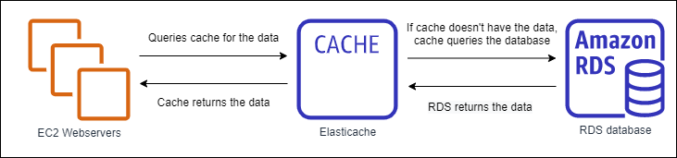
Running more webservers is incorrect since this is not the most cost-effective method.
Using HTTP protocol is incorrect since this is usually not desirable since this weakens the security of your traffic.
AWS uses the best network cables they can get from vendors. Improving their physical infrastructure is incorrect since this cannot be easily requested, so it is better to introduce improvements from your side instead.
References:
https://d1.awsstatic.com/whitepapers/AWS_Cloud_Best_Practices.pdf
https://aws.amazon.com/caching/aws-caching/
AWS Well-Architected Design Principles Cheat Sheet:
https://tutorialsdojo.com/aws-well-architected-framework-design-principles/

12. QUESTION
Category: CCP – Cloud Technology and Services
A company has noticed that whenever they enter the domain name of their Application Load Balancer (ALB) on a browser, they cannot reach one of their EC2 web servers behind the ALB. Which of the following should you first check to gain more insight on the issue?
- AWS CloudTrail
- AWS Config
- Amazon CloudWatch
- ELB Health Check (Correct)
The Application Load Balancer periodically sends requests to its registered targets to test their status. These tests are called health checks.
Each load balancer node routes requests only to the healthy targets in the enabled Availability Zones for the load balancer. Each load balancer node checks the health of each target using the health check settings for the target groups with which the target is registered. After your target is registered, it must pass one health check to be considered healthy. After each health check is completed, the load balancer node closes the connection that was established for the health check.
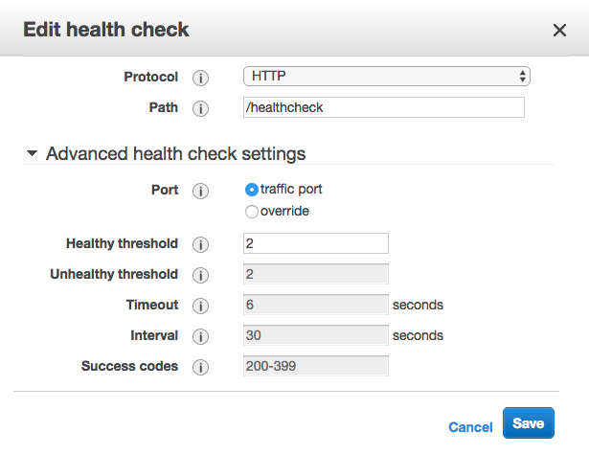
If a target group contains only unhealthy registered targets, the load balancer nodes route requests across its unhealthy targets.
In this scenario, a possible cause of why the company is not able to connect to an EC2 instance behind an ELB is that the load balancer deems the instance as unhealthy. This is verified by the ELB health checks that you can see in the ELB dashboard, which determines whether an instance is healthy or not. If the instance is unhealthy under the load balancer, then it will not receive any traffic.
Hence, the correct answer is: ELB Health Check.
Amazon CloudWatch is incorrect because this is just used to monitor your AWS resources and collect information in the form of logs, metrics, and events. Although this service can prove useful for investigation, it is not the first thing you should check in this scenario.
AWS CloudTrail is incorrect because this simply provides an event history of AWS account activity, including actions taken through the AWS Management Console, AWS SDKs, command line tools, and other AWS services. Although this service can prove useful for investigation, it is not the first thing you should check in this scenario.
AWS Config is incorrect because it just continuously monitors and records the AWS resource configurations and allows you to automate the evaluation of recorded configurations against desired configurations. This service will not help you very much in your investigation of the issue.

References:
https://docs.aws.amazon.com/elasticloadbalancing/latest/network/target-group-health-checks.html
https://docs.aws.amazon.com/elasticloadbalancing/latest/application/load-balancer-target-groups.html

13. QUESTION
Category: CCP – Cloud Technology and Services
Which of the following is a serverless compute service of AWS?
- Amazon Aurora
- AWS Lambda (Correct)
- Amazon DynamoDB
- Amazon Athena

AWS Lambda is a serverless compute service that lets you run code without provisioning or managing servers. You pay only for the compute time you consume – there is no charge when your code is not running. With Lambda, you can run code for virtually any type of application or backend service – all with zero administration. Just upload your code and Lambda takes care of everything required to run and scale your code with high availability.
AWS Lambda automatically scales your application by running code in response to each trigger. Your code runs in parallel and processes each trigger individually, scaling precisely with the size of the workload. With AWS Lambda, you are charged for every 1ms your code executes and the number of times your code is triggered.
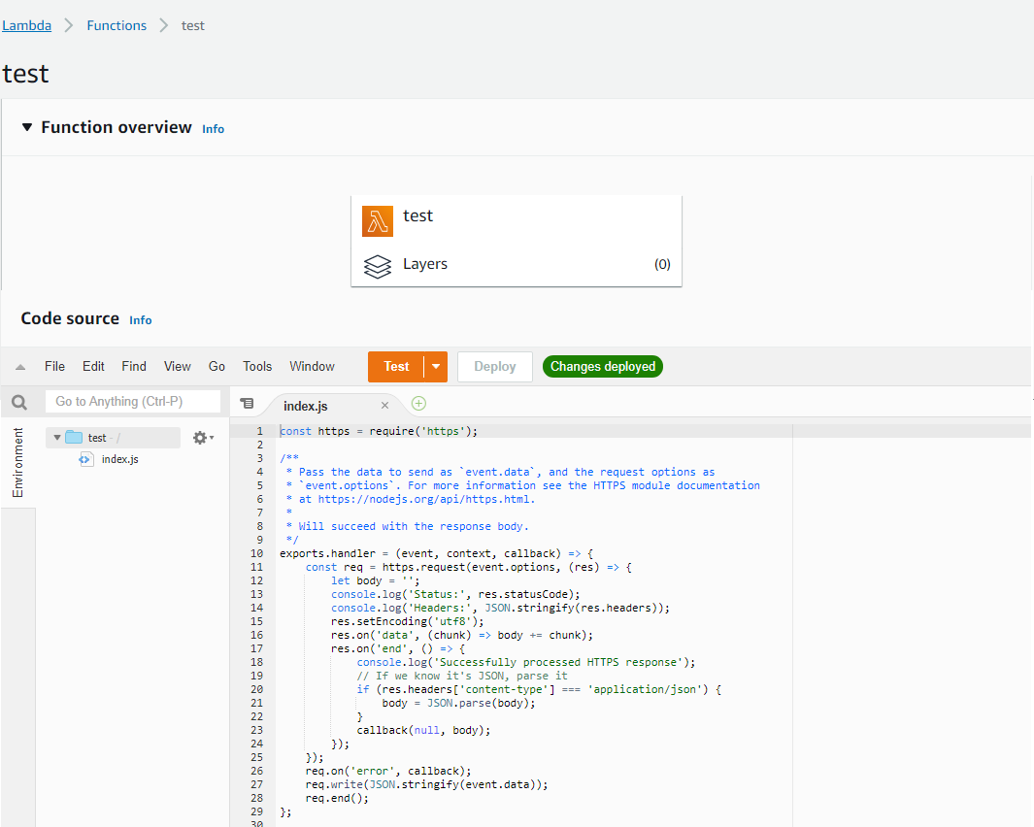
Hence, the correct answer is: AWS Lambda.
Amazon DynamoDB is incorrect since this is a fast, scalable NoSQL database service of AWS.
Amazon Aurora is also incorrect since this is primarily used as a database service and not a compute service. Although it has a serverless feature (Aurora Serverless), it is still used as a database and not for data processing.
Amazon Athena is incorrect since this service is an interactive query service that makes it easy to analyze data in Amazon S3 using standard SQL.
References:
https://aws.amazon.com/lambda/
https://docs.aws.amazon.com/lambda/latest/dg/welcome.html
Check out this AWS Lambda Cheat Sheet:
https://tutorialsdojo.com/aws-lambda/

14. QUESTION
Category: CCP – Cloud Technology and Services
Which type of Elastic Load Balancer allows you to forward the incoming request to a target group with a Lambda function as a target?
- Application Load Balancer (Correct)
- Gateway Load Balancer
- Network Load Balancer
- Both Gateway Load Balancer and Network Load Balancer
Elastic Load Balancing automatically distributes incoming application traffic across multiple targets, such as Amazon EC2 instances, containers, IP addresses, and Lambda functions. It can handle the varying load of your application traffic in a single Availability Zone or across multiple Availability Zones.
Elastic Load Balancing offers four types of load balancers that all feature the high availability, automatic scaling, and robust security necessary to make your applications fault-tolerant. They are:
Application Load Balancer – This is best suited for load balancing of HTTP and HTTPS traffic and provides advanced request routing targeted at the delivery of modern application architectures, including microservices and containers. Operating at the individual request level (Layer 7), Application Load Balancer routes traffic to targets within Amazon Virtual Private Cloud (Amazon VPC) based on the content of the request.
Network Load Balancer – This is best suited for load balancing of Transmission Control Protocol (TCP), User Datagram Protocol (UDP), and Transport Layer Security (TLS) traffic where extreme performance is required. Operating at the connection level (Layer 4), Network Load Balancer routes traffic to targets within Amazon Virtual Private Cloud (Amazon VPC) and is capable of handling millions of requests per second while maintaining ultra-low latencies. The network Load Balancer is also optimized to handle sudden and volatile traffic patterns.
Gateway Load Balancer – This provides both Layer 3 gateway and Layer 4 load balancing capabilities. It is a transparent bump-in-the-wire device that does not change any part of the packet. It is architected to handle millions of requests/second, volatile traffic patterns, and introduces extremely low latency.
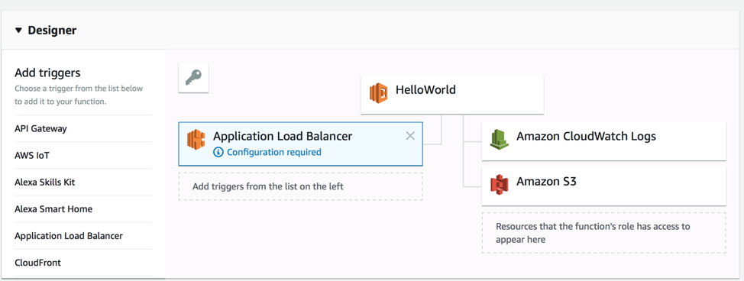
With your Application Load Balancer, you can register your Lambda functions as targets and configure a listener rule to forward requests to the target group for your Lambda function. When the load balancer forwards the request to a target group with a Lambda function as a target, it invokes your Lambda function and passes the content of the request to the Lambda function in JSON format.
Hence, the correct answer is: Application Load Balancer.
Network Load Balancer, and Gateway Load Balancer are incorrect because they don’t support Lambda functions as targets.

References:
https://docs.aws.amazon.com/elasticloadbalancing/latest/application/introduction.html#application-load-balancer-benefits
https://aws.amazon.com/elasticloadbalancing/features/?nc=sn&loc=2#Product_comparisons
Check out this AWS Elastic Load Balancing (ELB) Cheat Sheet:
https://tutorialsdojo.com/aws-elastic-load-balancing-elb/

Application Load Balancer vs Network Load Balancer vs Gateway Load Balancer:
https://tutorialsdojo.com/application-load-balancer-vs-network-load-balancer-vs-classic-load-balancer/

15. QUESTION
Category: CCP – Security and Compliance
A startup is recently migrated its infrastructure to the AWS cloud and wants to ensure that users can access the right resources. Which IAM service is responsible for enforcing privileges and access controls in your AWS environment?
- IAM Group
- IAM Policy (Correct)
- IAM User
- IAM Role
You manage access in AWS by creating IAM Policies and attaching them to IAM identities (users, groups of users, or roles) or AWS resources. A policy is an object in AWS that, when associated with an identity or resource, defines its permissions. AWS evaluates these policies when a principal uses an IAM entity (user or role) to make a request. Permissions in the policies determine whether the request is allowed or denied.
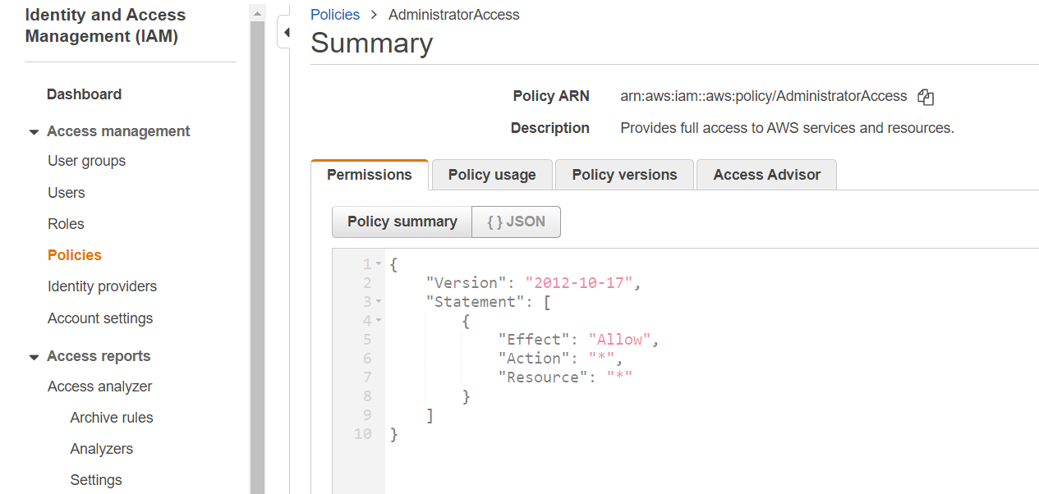
IAM Policy specifies and regulates Amazon resource permissions. It provides users and groups fine-grained control over the activities they can do on which AWS resources and is formatted as JSON documents, making it easy to read and write. Moreover, IAM Policy also supports versioning, enabling you to keep track of policy changes over time and revert versions if necessary. Access control is enforced via IAM Policy, which defines which users or groups can perform specific actions on resources and can be integrated with other Amazon services, such as AWS CloudTrail, to log and audit all API calls made to AWS resources. IAM Policy, therefore, offers a robust management tool for controlling access to Amazon resources and securing your AWS environment.
Hence the correct answer is: IAM Policy.
IAM User is incorrect because it represents a person or service that uses AWS resources and is in charge of authenticating and identifying AWS users.
IAM Group is incorrect because IAM Group is a collection of IAM users. It aids in simplifying the management of permissions for a group of IAM users.
IAM Role is incorrect because it refers to an IAM identity with specific permissions. Like an IAM user, an IAM role is an AWS identity with permission policies governing what the identity can and cannot do in AWS.On the other hand, an IAM Role is intended to be assumable by anyone who needs it.

References:
https://docs.aws.amazon.com/IAM/latest/UserGuide/introduction_access-management.html
https://docs.aws.amazon.com/IAM/latest/UserGuide/access_policies.html

Check out this AWS IAM Cheat Sheet:
https://tutorialsdojo.com/aws-identity-and-access-management-iam/

16. QUESTION
Category: CCP – Cloud Technology and Services
A Software Engineer is working on a new project for the company. The project entails creating a web application with the PHP framework and releasing it to the AWS Cloud. Given the company’s limited resources and the Software Engineer’s tight deadline, the Software Engineer must devise a plan for quickly deploying the application to AWS while avoiding the time-consuming process of setting up and configuring the infrastructure.
Which of the following service will allow the Software Engineer to quickly deploy their application into the AWS Cloud without building or launching the individual resources themselves?
- Amazon EBS
- Amazon ECS
- AWS Elastic Beanstalk (Correct)
- Amazon EKS

AWS Elastic Beanstalk is an easy-to-use service for deploying and scaling web applications and services developed with Java, .NET, PHP, Node.js, Python, Ruby, Go, and Docker on familiar servers such as Apache, Nginx, Passenger, and IIS.
You can simply upload your code and Elastic Beanstalk automatically handles the deployment, from capacity provisioning, load balancing, auto-scaling to application health monitoring. At the same time, you retain full control over the AWS resources powering your application and can access the underlying resources at any time.
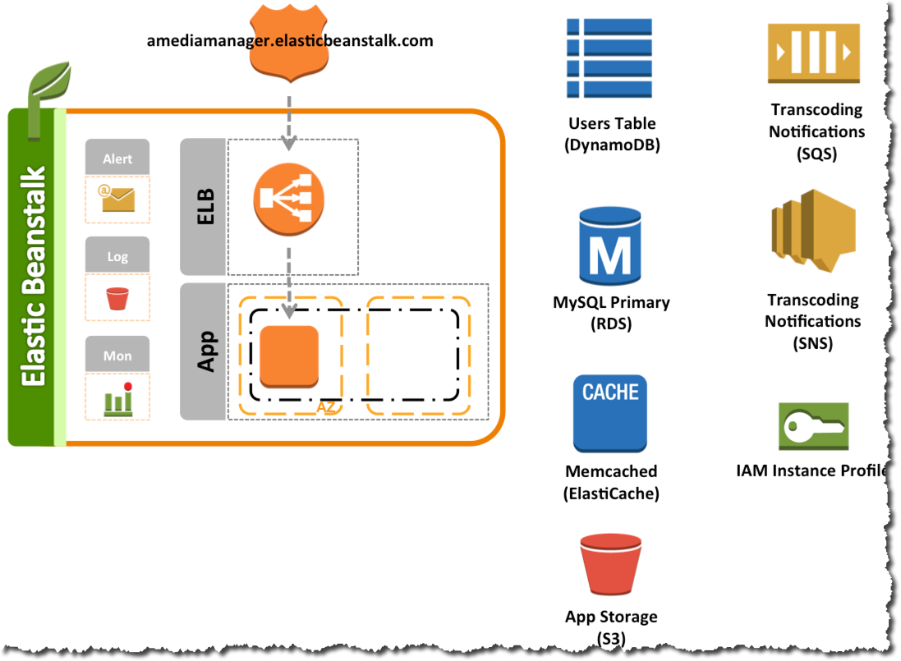
Elastic Beanstalk is the fastest and simplest way to deploy your application on AWS. You simply use the AWS Management Console, a Git repository, or an integrated development environment (IDE) such as Eclipse or Visual Studio to upload your application, and Elastic Beanstalk automatically handles the deployment details of capacity provisioning, load balancing, auto-scaling, and application health monitoring. Within minutes, your application will be ready to use without any infrastructure or resource configuration work on your part.
Hence, the correct answer is: AWS Elastic Beanstalk.
Amazon EBS is incorrect because this is a storage volume for EC2 instances and services that use EC2 as a backend.
Amazon ECS is incorrect since this is a compute service for Docker / containerized applications and you have to manually provision the infrastructure yourself.
Amazon EKS is incorrect because this is a Kubernetes solution of AWS and you have to manually provision the infrastructure yourself.

References:
https://aws.amazon.com/elasticbeanstalk/
https://aws.amazon.com/elasticbeanstalk/developer-resources/

17. QUESTION
Category: CCP – Cloud Technology and Services
Which security services in AWS use intelligent systems and machine learning to quickly identify potential security threats and issues in your AWS account? (Select TWO.)
- Amazon GuardDuty (Correct)
- Amazon Detective (Correct)
- AWS IAM
- AWS Sumerian
- Amazon Cognito

Amazon Detective makes it easy to analyze, investigate, and quickly identify the root cause of potential security issues or suspicious activities. Amazon Detective automatically collects log data from your AWS resources and uses machine learning, statistical analysis, and graph theory to build a linked set of data that enables you to easily conduct faster and more efficient security investigations.
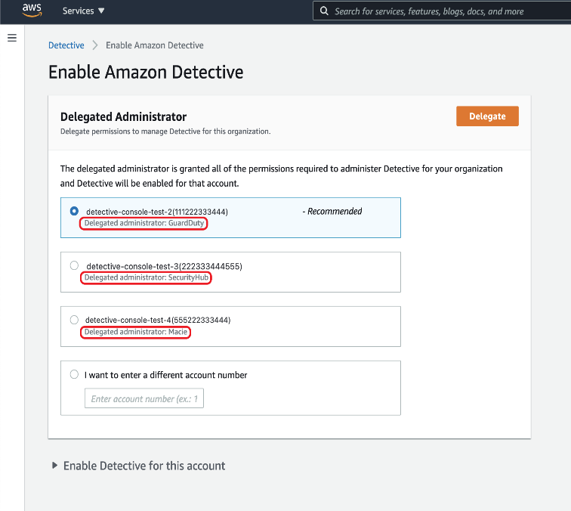
Amazon GuardDuty is a threat detection service that continuously monitors for malicious activity and unauthorized behavior to protect your AWS accounts, workloads, and data stored in Amazon S3. The service uses machine learning, anomaly detection, and integrated threat intelligence to identify and prioritize potential threats.
Hence, the correct answers are:
– Amazon Detective
– Amazon GuardDuty
AWS Sumerian is incorrect because this is a service that lets you create and run 3D, Augmented Reality (AR), and Virtual Reality (VR) applications.
Amazon Cognito is incorrect because this is just a service that enables you to authenticate users through an external identity provider and provides temporary security credentials to access your app’s resources in AWS.
AWS IAM is incorrect because this service is for the user and access management. Although it is a security service, it does not use machine learning to detect threats and issues in your AWS account.

References:
https://aws.amazon.com/detective/
https://aws.amazon.com/guardduty/

Check out these Amazon Detective and Amazon GuardDuty Cheat Sheets:
https://tutorialsdojo.com/amazon-detective/
https://tutorialsdojo.com/amazon-guardduty/

18. QUESTION
Category: CCP – Security and Compliance
What service should you use in order to add user sign-up, sign-in, and access control to your mobile app with a feature that supports sign-in with social identity providers such as Facebook, Google, and Amazon, and enterprise identity providers via SAML 2.0?
- Amazon Cognito (Correct)
- AWS Directory Service
- AWS Single Sign-On (SSO)
- AWS Identity and Access Management (IAM)

Amazon Cognito lets you add user sign-up, sign-in, and access control to your web and mobile apps quickly and easily. Amazon Cognito scales to millions of users and supports sign-in with social identity providers, such as Facebook, Google, and Amazon, and enterprise identity providers via SAML 2.0.
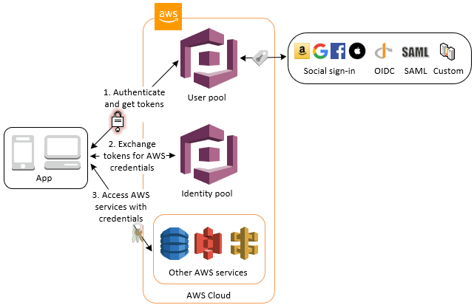
Amazon Cognito provides solutions to control access to backend resources from your app. You can define roles and map users to different roles so your app can access only the resources that are authorized for each user.
With a built-in UI and easy configuration for federating identity providers, you can integrate Amazon Cognito to add user sign-in, sign-up, and access control to your app in minutes. You can customize the UI to put your company branding front and center for all user interactions.
Hence, the correct answer is Amazon Cognito.
AWS Single Sign-On (SSO) is incorrect because this is a cloud SSO service that makes it easy to centrally manage SSO access to multiple AWS accounts and business applications. It doesn’t provide an easy way to add user sign-in, sign-up, and access control to your mobile app, unlike Amazon Cognito.
AWS Identity and Access Management (IAM) is incorrect because this service lets you to manage access to AWS services and resources securely.
AWS Directory Service is incorrect because it enables your directory-aware workloads and AWS resources to use managed Active Directory in the AWS Cloud.

References:
https://aws.amazon.com/cognito/
https://docs.aws.amazon.com/cognito/latest/developerguide/amazon-cognito-integrating-user-pools-with-identity-pools.html

Check out this Amazon Cognito Cheat Sheet:
https://tutorialsdojo.com/amazon-cognito/

19. QUESTION
Category: CCP – Cloud Concepts
Which AWS service lets you provision a logically isolated section of the AWS Cloud where you can launch AWS resources?
- Internet gateway
- AWS Elastic Beanstalk
- Amazon VPC (Correct)
- Amazon EC2

Amazon Virtual Private Cloud (Amazon VPC) lets you provision a logically isolated section of the AWS Cloud where you can launch AWS resources in a virtual network that you define. You have complete control over your virtual networking environment, including selection of your own IP address range, creation of subnets, and configuration of route tables and network gateways.
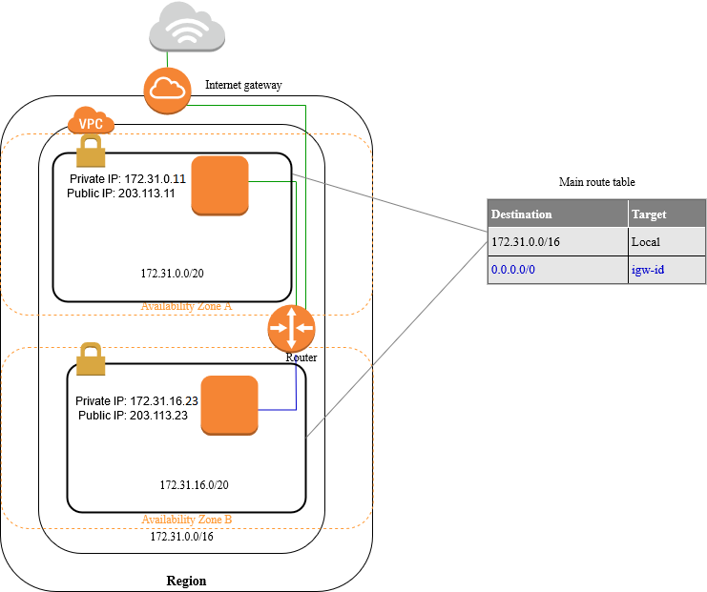
You can launch your AWS resources, such as Amazon EC2 instances, into your VPC. You can specify an IP address range for the VPC, add subnets, associate security groups, and configure route tables.
A subnet is a range of IP addresses in your VPC. You can launch AWS resources into a specified subnet. Use a public subnet for resources that must be connected to the internet, and a private subnet for resources that won’t be connected to the internet. To protect the AWS resources in each subnet, you can use multiple layers of security, including security groups and network access control lists (ACL).
Hence, the correct answer is Amazon VPC.
Internet gateway is incorrect because this is just a VPC component that enables your servers in the public subnet to communicate with the public Internet. It does not isolate a virtual network space for you to launch resources in.
Amazon EC2 is incorrect because this is simply a compute service where you can host your applications and other databases; essentially, a server. It does not isolate a virtual network space for you to launch resources in.
AWS Elastic Beanstalk is incorrect because this service is just a platform where you can easily deploy applications and the service handles the infrastructure provisioning process for you. It does not isolate a virtual network space for you to launch resources in.

References:
https://aws.amazon.com/vpc/
https://docs.aws.amazon.com/vpc/latest/userguide/what-is-amazon-vpc.html

Check out this Amazon VPC Cheat Sheet:
https://tutorialsdojo.com/amazon-vpc/

20. QUESTION
Category: CCP – Cloud Technology and Services
Which of the following is the most cost-effective service to use if you want to coordinate multiple AWS services into serverless workflows?
- AWS Batch
- AWS Step Functions (Correct)
- AWS Lambda
- Amazon SWF

AWS Step Functions provides serverless orchestration for modern applications. Orchestration centrally manages a workflow by breaking it into multiple steps, adding flow logic, and tracking the inputs and outputs between the steps. As your applications execute, Step Functions maintains application state, tracking exactly which workflow step your application is in, and stores an event log of data that is passed between application components. That means that if networks fail or components hang, your application can pick up right where it left off.
Application development is faster and more intuitive with Step Functions because you can define and manage the workflow of your application independently from its business logic. Making changes to one does not affect the other. You can easily update and modify workflows in one place, without having to struggle with managing, monitoring and maintaining multiple point-to-point integrations. Step Functions frees your functions and containers from excess code, so your applications are faster to write, more resilient, and easier to maintain.
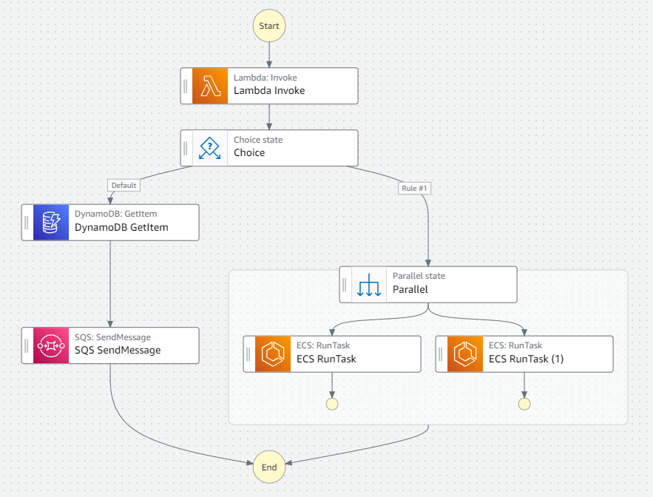
Hence, the correct answer is AWS Step Functions.
Amazon SWF is incorrect because it is just a fully-managed state tracker and task coordinator service. It does not provide serverless orchestration to multiple AWS resources.
AWS Lambda is incorrect because although this service is used for serverless computing, it does not provide a direct way to coordinate multiple AWS services into serverless workflows.
AWS Batch is incorrect because this is primarily used to efficiently run hundreds of thousands of batch computing jobs in AWS.

References:
https://aws.amazon.com/step-functions/features/
https://docs.aws.amazon.com/step-functions/latest/dg/welcome.html

Check out this AWS Step Functions Cheat Sheet:
https://tutorialsdojo.com/aws-step-functions/

Amazon Simple Workflow (SWF) vs AWS Step Functions vs Amazon SQS:
https://tutorialsdojo.com/amazon-simple-workflow-swf-vs-aws-step-functions-vs-amazon-sqs/

21. QUESTION
Category: CCP – Cloud Concepts
A company is planning to deploy its high-frequency trading (HFT) application which will store constantly changing financial data in AWS and require low latency access. Which AWS services below should you use? (Select TWO.)
- Amazon S3 Glacier Instant Retrieval
- AWS Snowball Edge
- Amazon EFS (Correct)
- Amazon RDS (Correct)
- Amazon S3
Amazon Elastic File System (Amazon EFS) provides simple, scalable file storage for use with Amazon EC2. With Amazon EFS, storage capacity is elastic, growing and shrinking automatically as you add and remove files, so your applications have the storage when they need it. Amazon EFS has a simple web services interface that allows you to create and configure file systems quickly and easily.
Amazon Relational Database Service (Amazon RDS) makes it easy to set up, operate, and scale a relational database in the cloud. It provides cost-efficient and resizable capacity while automating time-consuming administration tasks such as hardware provisioning, database setup, patching, and backups. It frees you to focus on your applications so you can give them the fast performance, high availability, security, and compatibility they need.
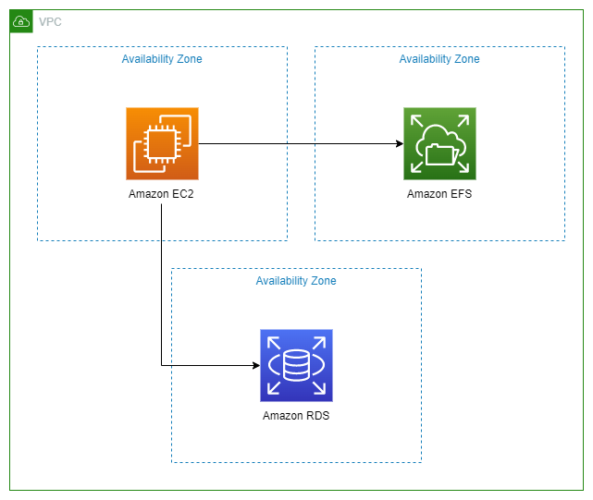
Amazon Simple Storage Service (Amazon S3) provides developers and IT teams with secure, durable, and highly scalable object storage at a very low cost. You can store and retrieve any amount of data, at any time, from anywhere on the web through a simple web service interface. You can write, read, and delete objects containing from zero to 5 TB of data. Amazon S3 is highly scalable, allowing concurrent read or write access to data by many separate clients or application threads.
If you are storing data that must be updated very frequently, you should consider using other services that take into account read and write latencies, such as Amazon EBS volumes, Amazon RDS, Amazon DynamoDB, Amazon EFS, or relational databases running on Amazon EC2.
Read and write latencies can occur if your storage service is not placed within your VPC or in the same Availability Zone of your EC2 instance. This means that it will take some time for your data to be sent over from your server to your data storage. Amazon EBS provides the lowest latency access to data from a single EC2 instance. This is because the EBS volume is directly attached to the EC2 instance and is also located at the same Availability Zone.
Hence, the correct answers are:
– Amazon EFS
– Amazon RDS
Amazon S3 Glacier Instant Retrieval is incorrect because this is just a low-cost storage service that provides highly secure, durable, and flexible storage for data archiving and online backup. This is not suitable to be used for applications with rapidly changing data.
AWS Snowball Edge is incorrect because this is primarily used for data migration, where you need to move large amounts of data into and out of AWS.
Amazon S3 is incorrect. Although you can technically use this service as a data storage for rapidly changing data, this entails high latency since S3 is located outside of your VPC.

References:
https://d0.awsstatic.com/whitepapers/AWS%20Storage%20Services%20Whitepaper-v9.pdf
https://aws.amazon.com/products/storage/

Check out these Amazon EFS and RDS Cheat Sheets:
https://tutorialsdojo.com/amazon-efs/
https://tutorialsdojo.com/amazon-relational-database-service-amazon-rds/

22. QUESTION
Category: CCP – Billing, Pricing and Support
Which of the following provides you access to Reserved Instance (RI) purchase recommendations based on your past usage and indicate potential opportunities for savings as compared to On-Demand usage?
- AWS Billing Dashboard
- AWS Cost and Usage report
- AWS Budgets
- AWS Cost Explorer (Correct)

If you enable Cost Explorer, you automatically get Amazon EC2, Amazon RDS, ElastiCache, Amazon ES, and Amazon Redshift Reserved Instance (RI) purchase recommendations that could help you reduce your costs. RIs provide a discounted hourly rate (up to 75%) compared to On-Demand pricing.
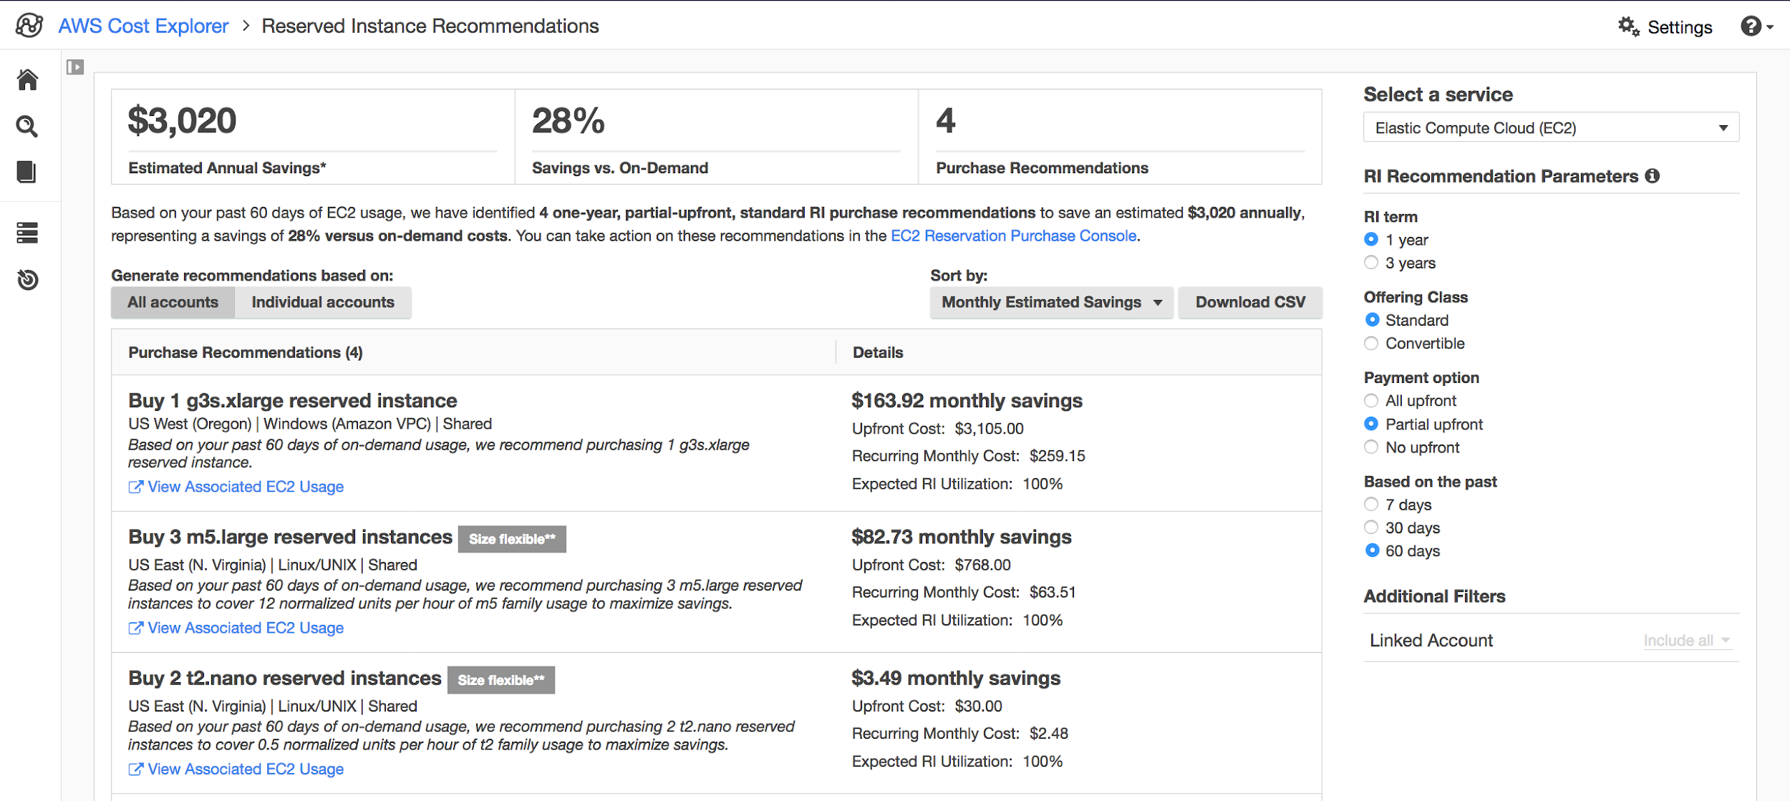
Cost Explorer generates your RI recommendations using the following process:
– Identifies your On-Demand Instance usage for a service during a specific time period
– Collects your usage into categories that are eligible for an RI
– Simulates every combination of RIs in each category of usage
– Identifies the best number of each type of RI to purchase to maximize your estimated savings
For example, Cost Explorer automatically aggregates your Amazon EC2 Linux, shared tenancy, and c4 family usage in the US West (Oregon) Region and recommends that you buy size-flexible regional RIs to apply to the c4 family usage. Cost Explorer recommends the smallest size instance in an instance family. This makes it easier to purchase a size-flexible RI. Cost Explorer also shows the equal number of normalized units so that you can purchase any instance size that you want. For this example, your RI recommendation would be for c4.large because that is the smallest size instance in the c4 instance family.
Cost Explorer recommendations are based on a single account or organization usage of the past seven, 30, or 60 days. Cost Explorer ignores usage that is already covered by an RI. Amazon EC2, ElastiCache, Amazon ES, and Amazon Redshift recommendations are for RIs scoped to Region, not Availability Zones, and your estimated savings reflects the application of those RIs to your usage. Amazon RDS recommendations are scoped to either Single-AZ or Multi-AZ RIs. Cost Explorer updates your recommendations at least once every 24 hours.
Hence, the correct answer is: AWS Cost Explorer.
AWS Billing Dashboard, AWS Budgets, and AWS Cost and Usage report are all incorrect since these tools do not provide Reserved Instance (RI) purchase recommendations, unlike AWS Cost Explorer.

References:
https://docs.aws.amazon.com/awsaccountbilling/latest/aboutv2/ri-recommendations.html
https://docs.aws.amazon.com/awsaccountbilling/latest/aboutv2/ce-rightsizing.html

Check out this AWS Billing and Cost Management Cheat Sheet:
https://tutorialsdojo.com/aws-billing-and-cost-management/

23. QUESTION
Category: CCP – Cloud Technology and Services
A company is using Amazon S3 to store various types of documents in a single bucket, and different teams frequently access the stored objects. If the document is accidentally overwritten or deleted, the data must be recoverable. Which of the following S3 features should they use?
- S3 Versioning (Correct)
- S3 Event Notifications
- S3 Glacier Vault Lock
- S3 Lifecycle
Amazon S3 has various features you can use to organize and manage your data in ways that support specific use cases, enable cost efficiencies, enforce security, and meet compliance requirements. S3 features include capabilities to append metadata tags to objects, move and store data across the S3 Storage Classes, configure and enforce data access controls, secure data against unauthorized users, run big data analytics, monitor data at the object and bucket levels, and view storage usage and activity trends across your organization. Objects can be accessed through S3 Access Points or directly through the bucket hostname.
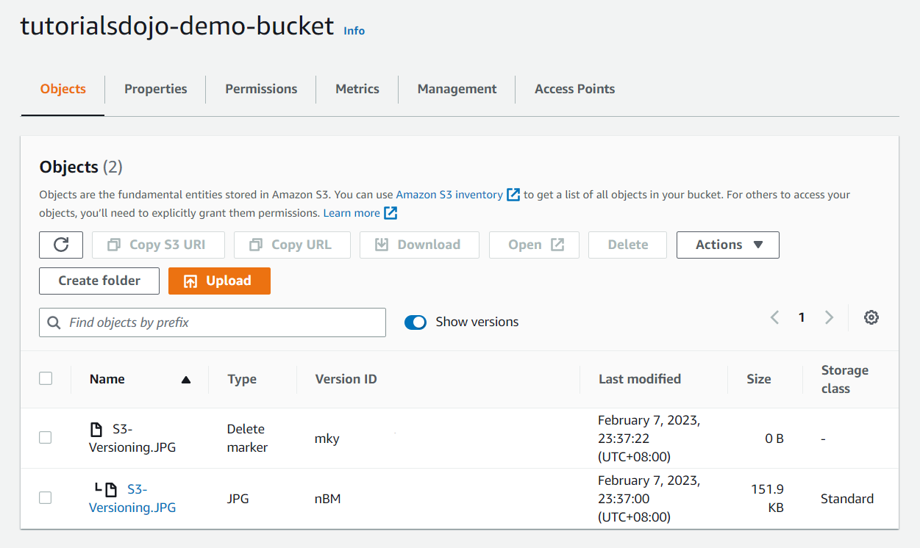
If you enabled S3 versioning during the bucket creation, every time you upload an object, it will automatically create a version of it. So, if you accidentally overwrite an object, you can still use versioning to restore the previous object.
The above image depicts two types of objects: a delete marker and a JPG. The main reason for this is that when an object is deleted, Amazon S3 inserts a delete marker that replaces the object as the current version instead of completely removing it. As part of best practice, AWS recommends versioning to recover objects from being deleted or overwritten by mistake.
Hence, the correct answer is: S3 Versioning.
S3 Lifecycle is incorrect because this just transitions your object storage class to a different tier and will not help you recover data if you delete the object.
S3 Event Notifications is incorrect because this only sends you notifications of specified bucket events. For example, when you upload an object, the S3 will trigger an Amazon SNS topic to send you an email that there is a newly uploaded object.
S3 Glacier Vault Lock is incorrect because even though this protects the objects from accidental deletion, you still can’t create various versions of your objects. Also, this is a feature of S3 Glacier. Take note that in the scenario, the company is using Amazon S3, which is frequently accessed by different teams. Therefore, the correct feature to use is S3 Versioning.

References:
https://docs.aws.amazon.com/AmazonS3/latest/userguide/Versioning.html
https://aws.amazon.com/s3/features/

Check out this Amazon S3 Cheat Sheet:
https://tutorialsdojo.com/amazon-s3/

24. QUESTION
Category: CCP – Cloud Technology and Services
What service allows you to create alarms that notify you when EC2 CPU Utilization thresholds are breached?
- Amazon SNS
- AWS Config
- AWS Auto Scaling
- Amazon CloudWatch (Correct)

Amazon CloudWatch monitors your Amazon Web Services (AWS) resources and the applications you run on AWS in real time. You can use CloudWatch to collect and track metrics, which are variables you can measure for your resources and applications.
The CloudWatch home page automatically displays metrics about every AWS service you use. You can additionally create custom dashboards to display metrics about your custom applications, and display custom collections of metrics that you choose.

You can create alarms which watch metrics and send notifications or automatically make changes to the resources you are monitoring when a threshold is breached. For example, you can monitor the CPU usage and disk reads and writes of your Amazon EC2 instances and then use this data to determine whether you should launch additional instances to handle increased load. You can also use this data to stop under-used instances to save money.
You can create a CloudWatch alarm that watches a single CloudWatch metric or the result of a math expression based on CloudWatch metrics. The alarm performs one or more actions based on the value of the metric or expression relative to a threshold over a number of time periods. The action can be an Amazon EC2 action, an Amazon EC2 Auto Scaling action, or a notification sent to an Amazon SNS topic.
Hence, the correct answer is Amazon CloudWatch.
Amazon SNS is incorrect because this service alone cannot capture metrics inputs from EC2 and create alarms out of it. It relies on another service such as CloudWatch Alarms to forward the actual alarm so that it can notify its subscribers of the issue.
AWS Config is incorrect because this is just a compliance checking tool and does not monitor resource metrics.
Amazon EC2 Auto Scaling is incorrect because the primary function of this is to help you maintain application availability and allows you to automatically add or remove EC2 instances according to conditions you define. It cannot create alarms that notify you if certain thresholds are breached. You should integrate auto-scaling with CloudWatch alarms to create a highly efficient, scalable system.

References:
https://docs.aws.amazon.com/AmazonCloudWatch/latest/monitoring/AlarmThatSendsEmail.html
https://aws.amazon.com/blogs/aws/amazon-cloudwatch-alarms/

Check out this Amazon CloudWatch Cheat Sheet:
https://tutorialsdojo.com/amazon-cloudwatch/

25. QUESTION
Category: CCP – Security and Compliance
What service acts as a firewall for your EC2 instances?
- Network ACL
- Security Group (Correct)
- Elastic Network Interface
- VPC

A security group acts as a virtual firewall for your instance to control inbound and outbound traffic. When you launch an instance in a VPC, you can assign up to five security groups to the instance. Security groups act at the instance level, not the subnet level. Therefore, each instance in a subnet in your VPC could be assigned to a different set of security groups. If you don’t specify a particular group at launch time, the instance is automatically assigned to the default security group for the VPC.
For each security group, you add rules that control the inbound traffic to instances, and a separate set of rules that control the outbound traffic. This section describes the basic things you need to know about security groups for your VPC and their rules.
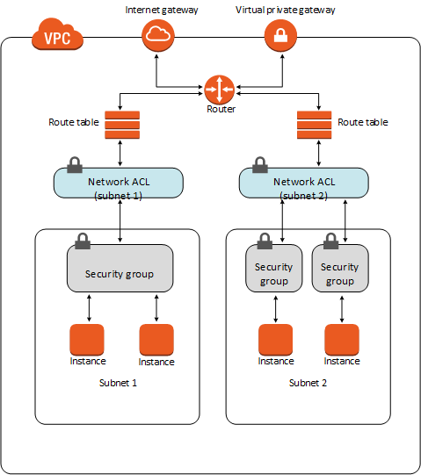

Hence, the correct answer is Security Group.
Network ACL is incorrect because this is primarily used to protect your subnets by controlling inbound and outbound traffic. They are not used to secure resources at an instance level.
Elastic Network Interface is incorrect because this is just a logical networking component in a VPC that represents a virtual network card. It does not serve as a virtual firewall for your instances.
Amazon VPC is incorrect because this simply lets you provision a logically isolated section of the AWS Cloud where you can launch AWS resources in a virtual network that you define. A VPC does not serve as a virtual firewall for your instances.

References:
https://docs.aws.amazon.com/vpc/latest/userguide/VPC_SecurityGroups.html
https://docs.aws.amazon.com/AWSEC2/latest/UserGuide/using-network-security.html

Check out these Tutorials Dojo Cheat Sheets:
https://tutorialsdojo.com/amazon-elastic-compute-cloud-amazon-ec2/
https://tutorialsdojo.com/amazon-vpc/
https://tutorialsdojo.com/security-group-vs-nacl/

26. QUESTION
Category: CCP – Cloud Concepts
Which of the following infrastructure correlates to a VPC’s subnet?
- Availability zone (Correct)
- Region
- Server
- Edge location

A VPC spans all the Availability Zones in the region. After creating a VPC, you can add one or more subnets in each Availability Zone. Each subnet must reside entirely within one Availability Zone and cannot span zones. Availability Zones are distinct locations that are engineered to be isolated from failures in other Availability Zones. By launching instances in separate Availability Zones, you can protect your applications from the failure of a single location.

If a subnet’s traffic is routed to an Internet gateway, the subnet is known as a public subnet. If you want your instance in a public subnet to communicate with the Internet over IPv4, it must have a public IPv4 address or an Elastic IP address (IPv4).
Hence, the correct answer is: Availability zone.
Both AWS Regions and Edge locations are incorrect because subnets are not directly correlated with these two.
Server is incorrect because subnets are part of a VPC within the AWS global network. Subnets are not bound by servers in any way.

References:
https://docs.aws.amazon.com/vpc/latest/userguide/VPC_Subnets.html
https://aws.amazon.com/about-aws/global-infrastructure/

27. QUESTION
Category: CCP – Cloud Concepts
What is the minimum support plan that will provide you access to all Trusted Advisor Checks?
- Basic
- Enterprise
- Business (Correct)
- Developer

AWS Support offers a range of plans that provide access to tools and expertise that support the success and operational health of your AWS solutions. All support plans provide 24×7 access to customer service, AWS documentation, whitepapers, and support forums. For technical support and more resources to plan, deploy, and improve your AWS environment, you can select a support plan that best aligns with your AWS use case.
It is important to know what services each support plan offers, and how they will matter to your company. Both business and enterprise support plans provide the full set of trusted advisor checks. The Developer plan only allows you access to the 7 core Trusted Advisor checks.

Since the question is asking for the minimum support plan available, the Business support plan will allow you to access all Trusted Advisor checks.
Hence, the correct answer is: Business support plan.
Basic and Developer support plans are incorrect because these will only allow you access to the 7 core Trusted Advisor checks.
Enterprise support plan is incorrect because although it provides the full set of trusted advisor checks, it costs a lot more than the Business support plan.

Reference:
https://aws.amazon.com/premiumsupport/plans/
https://docs.aws.amazon.com/awssupport/latest/user/getting-started.html

Check out this AWS Trusted Advisor Cheat Sheet:
https://tutorialsdojo.com/aws-trusted-advisor/

28. QUESTION
Category: CCP – Cloud Technology and Services
________ is AWS’s digital user engagement service that enables AWS customers to effectively communicate with their end users and measure user engagement across multiple channels including email, Text Messaging (SMS) and Mobile Push Notifications.
- Amazon SNS Mobile Push
- Amazon Simple Email Service
- Amazon Simple Notification Service
- Amazon Pinpoint (Correct)

Amazon Pinpoint is AWS’s Digital User Engagement Service that enables AWS customers to effectively communicate with their end-users and measure user engagement across multiple channels including email, Text Messaging (SMS) and Mobile Push Notifications.
Amazon Pinpoint also provides tools that enable audience management and segmentation, campaign management, scheduling, template management, A/B testing, analytics and data integration. It captures data to track deliverability as well as usage and messaging analytics covering a range of dimensions including user, channels and custom attributes.
Amazon Pinpoint is built on a service-based architecture. Developers can extend their applications and backend services in various ways, including: sending messages directly from their applications via the Amazon Pinpoint channels (Email, SMS and Mobile Push), accessing segmentation data to alter their application behavior for segments of users, create and run campaigns directly from their applications, and access deliverability and analytics data to improve the user engagement of their applications. The system empowers customers to send the right message, to the right audience, at the right time and on the most effective channel.

Hence, the correct answer is: Amazon Pinpoint.
Amazon Simple Notification Service is incorrect because this is a fully managed pub/sub messaging service that enables you to decouple microservices, distributed systems, and serverless applications.
Amazon Simple Email Service is incorrect because this is a cloud-based email sending service designed to help digital marketers and application developers send marketing, notification, and transactional emails.
Amazon SNS Mobile Push is incorrect because this is a feature of Amazon SNS that pushes notification messages to both mobile devices and desktops. This is not considered as a fully-fledged digital user engagement service, unlike Amazon Pinpoint.
References:
https://aws.amazon.com/pinpoint/
http://docs.aws.amazon.com/pinpoint/latest/userguide/welcome.html

29. QUESTION
Category: CCP – Cloud Concepts
Which of the following practices demonstrate operational excellence in AWS cloud? (Select TWO.)
- Perform monthly game days on your AWS environment (Correct)
- Launching your infrastructure manually via the Console
- Use serverless applications such as AWS Lambda
- Monitor EC2 metric consumption and adjust the instance type accordingly
- Deploy small, incremental changes to your production servers using AWS CodeDeploy (Correct)

The Well-Architected Framework has been developed to help cloud architects build secure, high-performing, resilient, and efficient infrastructure for their applications. This is based on six pillars namely:
1. Operational Excellence
2. Security
3. Reliability
4. Performance Efficiency
5. Cost Optimization
6. Sustainability
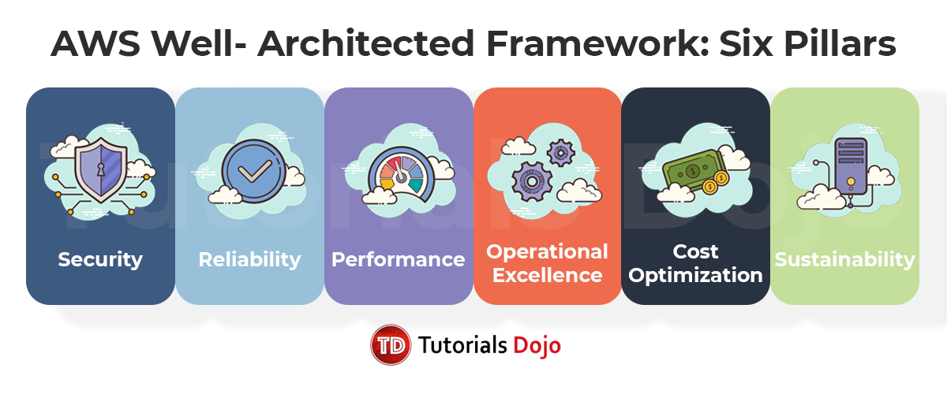
This Framework provides a consistent approach for customers and partners to evaluate architectures, and implement designs that will scale over time.
The AWS Well-Architected Framework helps you understand the pros and cons of decisions you make while building systems on AWS. By using this Framework, you will learn architectural best practices for designing and operating reliable, secure, efficient, and cost-effective systems in the cloud. It provides a way for you to consistently measure your architectures against best practices and identify areas for improvement. The process for reviewing an architecture is a constructive conversation about architectural decisions and is not an audit mechanism. Having well-architected systems greatly increases the likelihood of business success.
The operational excellence pillar focuses on running and monitoring systems to deliver business value, and continually improving processes and procedures. Key topics include managing and automating changes, responding to events, and defining standards to successfully manage daily operations.
Using tools such as AWS CodeDeploy to deploy small, incremental changes to your application ensures that you do not introduce drastic updates that may affect your application entirely. Performing monthly game days allows you to test your environment for different failure scenarios so you can quickly plan out ways to remediate them.
Hence, the correct answers are: Deploy small, incremental changes to your production servers using AWS CodeDeploy and Perform monthly game days on your AWS environment.
The option that says: Launching your infrastructure manually via the console is incorrect because this is not a notable best practice under operational excellence. In the cloud, it is preferred to automate the majority of the tasks to achieve a predictable and constant result.
The option that says: Using serverless applications such as AWS Lambda is incorrect because this is more of a design principle that focuses on performance efficiency and not operational excellence. Serverless is a very useful tool that steers away from traditional server management and lets you focus more on your applications and services.
The option that says: Monitoring EC2 consumption and adjusting your instance type accordingly is incorrect because this is more related to the performance efficiency pillar. Underprovisioned instances need to be scaled up to deliver better performance. Overprovisioned instances need to be scaled down to save on costs.

References:
https://aws.amazon.com/architecture/well-architected/
https://docs.aws.amazon.com/wellarchitected/latest/framework/welcome.html

AWS Well-Architected Framework – Six Pillars Cheat Sheet:
https://tutorialsdojo.com/aws-well-architected-framework-five-pillars

30. QUESTION
Category: CCP – Cloud Technology and Services
Which AWS service lets you provision either Windows or Linux desktops in just a few minutes and can scale easily to provide thousands of desktops to workers?
- Amazon Workspaces (Correct)
- AWS Organizations
- AWS Cloud9
- AWS Systems Manager

Amazon WorkSpaces is a managed, secure Desktop-as-a-Service (DaaS) solution where you provision either Windows or Linux desktops in just a few minutes and quickly scale to provide thousands of desktops to workers across the globe.
For both Windows and Amazon Linux WorkSpaces, each WorkSpace is associated with a virtual private cloud (VPC), and a directory to store and manage information for your WorkSpaces and users. Directories are managed through the AWS Directory Service, which offers the following options: Simple AD, AD Connector, or AWS Directory Service for Microsoft Active Directory, also known as AWS Managed Microsoft AD.
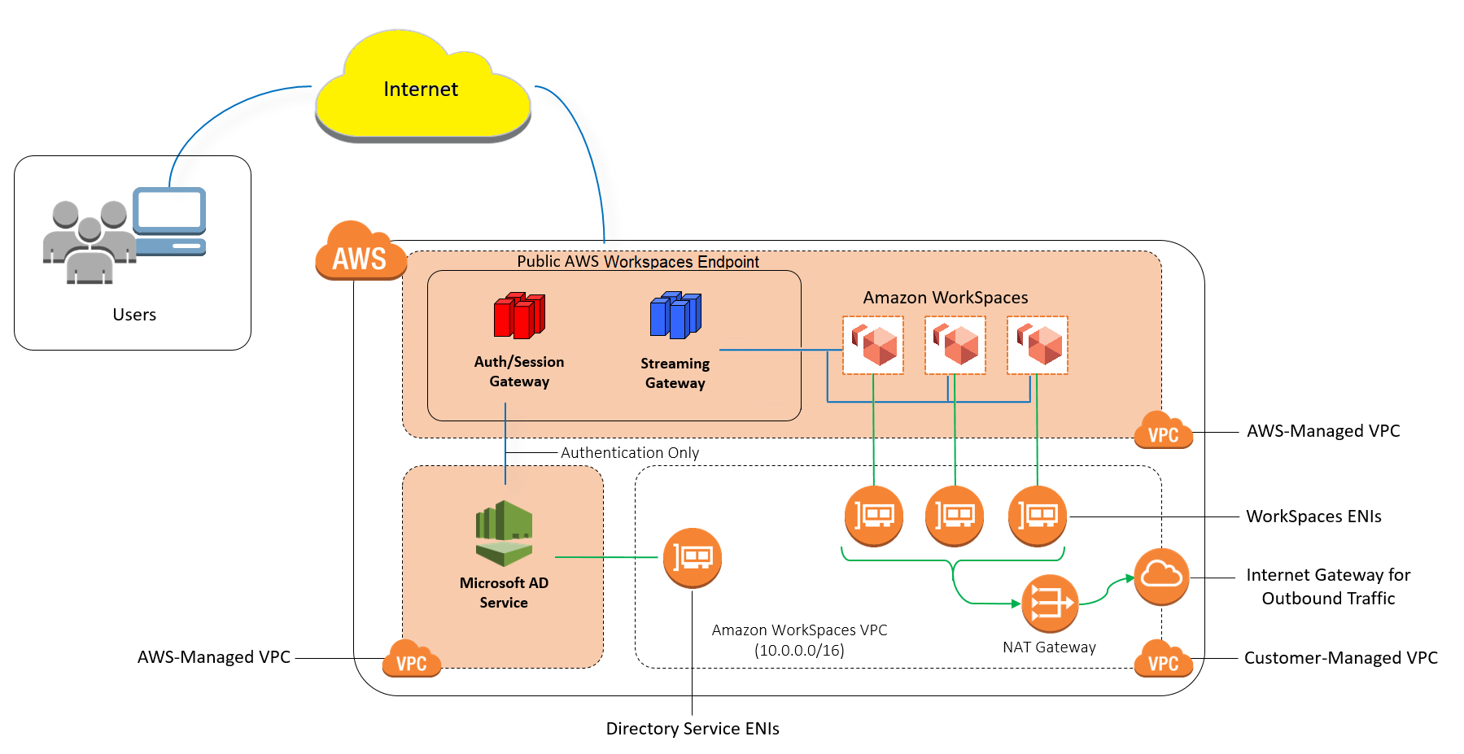
Hence, the correct answer is Amazon WorkSpaces.
AWS Organizations is incorrect because this just helps you to centrally govern your environment as you grow and scale your workloads on AWS. You cannot launch virtual desktops using AWS Organizations.
AWS Systems Manager is incorrect because this just provides a unified user interface so you can view operational data from multiple AWS services and allows you to automate operational tasks across your AWS resources. You can perform actions such as automation, run specific commands to your EC2 instances, apply patch management, etc.
AWS Cloud9 is incorrect because this is simply a cloud-based integrated development environment (IDE) that lets you write, run, and debug your code with just a browser. It includes a code editor, debugger, and terminal.

References:
https://aws.amazon.com/workspaces/
http://docs.aws.amazon.com/workspaces/latest/adminguide

Check out this Amazon Workspaces Cheat Sheet:
https://tutorialsdojo.com/amazon-workspaces/

31. QUESTION
Category: CCP – Cloud Technology and Services
What is the primary reason why you should be using an elastic load balancer for a website with high activity?
- ELBs help you scale servers easily without manual intervention
- ELBs can distribute traffic equally to your backend targets to handle the incoming traffic load (Correct)
- ELBs help tighten security through the use of security groups
- ELBs boost your website’s overall performance

Elastic Load Balancing automatically distributes incoming application traffic across multiple targets, such as Amazon EC2 instances, containers, IP addresses, and Lambda functions. It can handle the varying load of your application traffic in a single Availability Zone or across multiple Availability Zones.
Elastic Load Balancing offers three types of load balancers that all feature the high availability, automatic scaling, and robust security necessary to make your applications fault-tolerant. They are Application Load Balancer, Network Load Balancer, and Gateway Load Balancer.
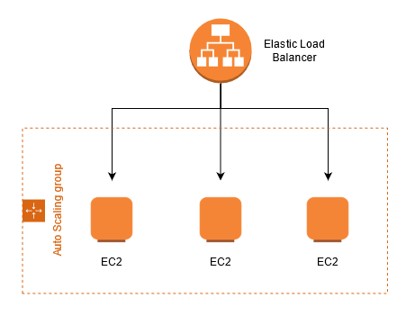
Hence, the correct answer is: ELBs can distribute traffic equally to your backend targets to handle the incoming traffic load.
The option that says: ELBs help you scale easily without manual intervention is incorrect. For automatic scaling of your compute capacity, you need another service called AWS Auto Scaling to go with your load balancers. Auto-scaling handles the scaling of capacity for you so that your instances are not being overwhelmed.
The option that says: ELBs help tighten security through the use of security groups is incorrect. Although ELBs do add security for your instances, it is not solely because of security groups. Security groups can be used directly with EC2 instances, so this statement is not the best answer for the scenario.
The option that says: ELBs boost your website’s overall performance is incorrect because ELBs do not boost website performance. This is usually done by another AWS service known as Amazon CloudFront. ELBs redirect traffic to healthy instances in a controlled manner, providing you the elasticity and fault tolerance that your applications need.

References:
https://docs.aws.amazon.com/elasticloadbalancing/latest/userguide/what-is-load-balancing.html
https://aws.amazon.com/elasticloadbalancing/features/

Check out this AWS Elastic Load Balancing Cheat Sheet:
https://tutorialsdojo.com/aws-elastic-load-balancing-elb/

Application Load Balancer vs Network Load Balancer vs Gateway Load Balancer:
https://tutorialsdojo.com/application-load-balancer-vs-network-load-balancer-vs-gateway-load-balancer/

32. QUESTION
Category: CCP – Cloud Technology and Services
A DevOps Engineer hosted an e-commerce website on AWS in the US East (Northern Virginia) region. Due to recent regulatory changes, the company decided to expand its operations and launch a new instance of the e-commerce website in the Europe (London) region. The DevOps Engineer’s task is to replicate the entire infrastructure of the existing e-commerce website in the new region with the least possible downtime.
Which of the following is best to replicate the entire infrastructure to another AWS Region with the least possible downtime?
- Enable RDS multi-AZ to have a similar database instance running in the new region
- Create a golden AMI which you can use to redeploy your instances to the new region
- Create a CloudFormation template and deploy it in the new region (Correct)
- Take an EBS snapshot on all your storage devices and copy them to the new region

AWS CloudFormation provides a common language for you to describe and provision all the infrastructure resources in your cloud environment. CloudFormation allows you to use programming languages or a simple text file to model and provision, in an automated and secure manner, all the resources needed for your applications across all regions and accounts. By turning your infra into code, you can deploy the code in your other regions.
AWS CloudFormation allows you to model your entire infrastructure with either a text file or programming languages. This provides a single source of truth for your AWS resources and helps you to standardize infrastructure components used across your organization, enabling configuration compliance and faster troubleshooting.
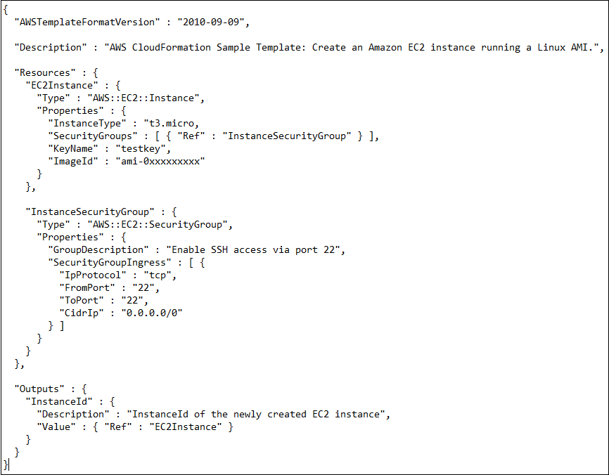
Hence, the correct answer is: Create a CloudFormation template and deploy it in the new region.
The option that says: Take an EBS snapshot on all your storage devices and copy them to the new region is incorrect since EBS contains EC2 data, not your whole infrastructure.
The option that says: Create a golden AMI which you can use to redeploy your instances to the new region is incorrect since you only create a copy of your EC2 instances. You might have other resources in your environment that have to be transferred too.
The option that says: Enable RDS Multi-AZ to have a similar database instance running in the new region is incorrect since doing this does not create a copy of your infrastructure in another region.

References:
https://aws.amazon.com/cloudformation/
https://docs.aws.amazon.com/AWSCloudFormation/latest/UserGuide/Welcome.html

Check out this AWS CloudFormation Cheat Sheet:
https://tutorialsdojo.com/aws-cloudformation/

33. QUESTION
Category: CCP – Cloud Technology and Services
Which service in AWS allows you to host your own Puppet Enterprise infrastructure?
- AWS Elastic Beanstalk
- AWS CloudFormation
- AWS Service Catalog
- AWS Opsworks (Correct)

AWS OpsWorks for Puppet Enterprise is a configuration management service that provides managed instances of Puppet. Puppet is an automation platform that allows you to use code to automate the configurations of your servers. OpsWorks lets you use Puppet to automate how servers are configured, deployed, and managed across your Amazon EC2 instances or on-premises compute environments.
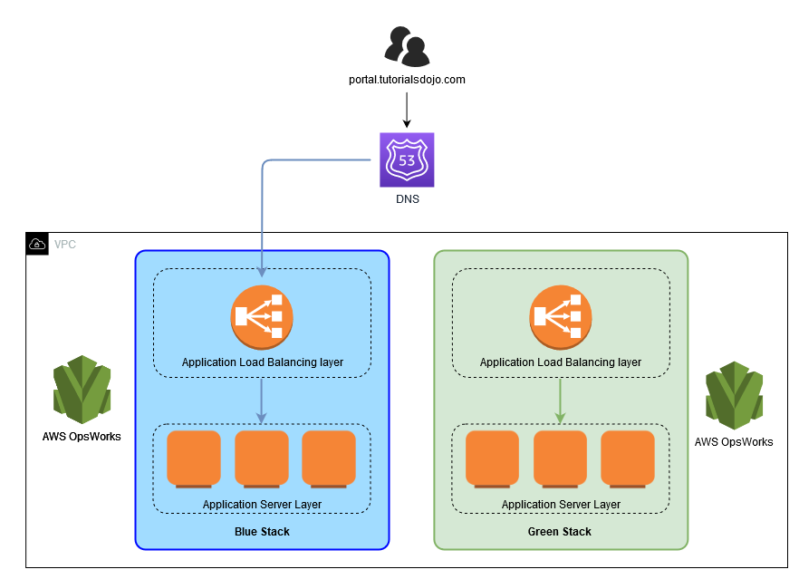
Hence, the correct answer is: AWS Opsworks.
AWS CloudFormation allows you to set up your infrastructure using JSON or YAML code. You can easily provision and configure the resources you need in your AWS environment. CloudFormation does not use Puppet, nor is it a platform used for web servers configuration management.
AWS Elastic Beanstalk allows you to simply upload your application while the service automatically handles the deployment, from capacity provisioning, load balancing, auto-scaling to application health monitoring, for you. Elastic Beanstalk does not use Puppet, nor is it a platform used for web servers configuration management.
AWS Service Catalog allows you to centrally manage commonly deployed IT services, and helps you achieve consistent governance and meet your compliance requirements, while enabling users to quickly deploy only the approved IT services they need. Service Catalog does not use Puppet, nor is it a platform used for web servers configuration management.

Reference:
https://aws.amazon.com/opsworks/puppetenterprise/

Check out this AWS OpsWorks Cheat Sheet:
https://tutorialsdojo.com/aws-opsworks/

34. QUESTION
Category: CCP – Cloud Concepts
Which of the following is the responsibility of the customer in the AWS cloud? (Select TWO.)
- Managing data stored in the AWS resources (Correct)
- Disposal of disk drives
- Upgrading chipsets to the latest commercially available product
- Managing users in their AWS account (Correct)
- Ensuring that AWS services comply with the standards required of them

Deploying workloads on Amazon Web Services (AWS) helps streamline time-to-market, increase business efficiency, and enhance user performance for many organizations. But as you capitalize on this strategy, it is important to understand your role in securing your AWS environment. Based on the AWS Shared Responsibility Model, AWS provides a data center and network architecture built to meet the requirements of the most security-sensitive organizations, while you are responsible for securing services built on top of this infrastructure, notably including network traffic from remote networks.
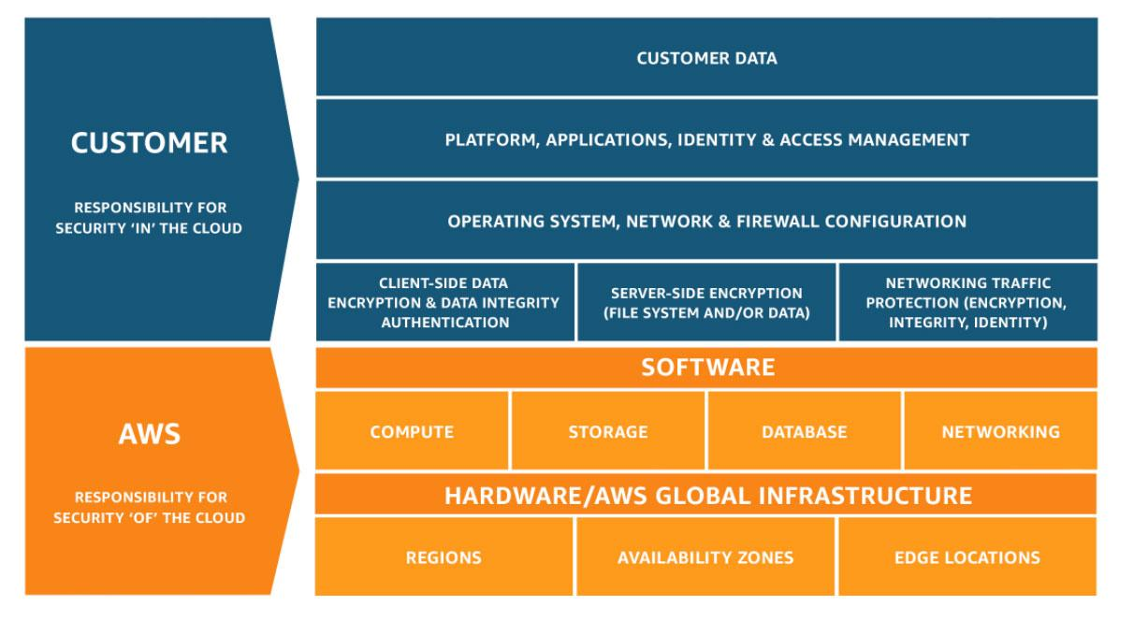
This customer/AWS shared responsibility model also extends to IT controls. Just as the responsibility to operate the IT environment is shared between AWS and its customers, so is the management, operation and verification of IT controls shared. AWS can help relieve customer burden of operating controls by managing those controls associated with the physical infrastructure deployed in the AWS environment that may previously have been managed by the customer. As every customer is deployed differently in AWS, customers can take advantage of shifting management of certain IT controls to AWS which results in a (new) distributed control environment.
Customers can then use the AWS control and compliance documentation available to them to perform their control evaluation and verification procedures as required. Below are examples of controls that are managed by AWS, AWS Customers and/or both.
Inherited Controls: Controls which a customer fully inherits from AWS.
Examples include:
– Physical and Environmental controls
Shared Controls: Controls which apply to both the infrastructure layer and customer layers, but in completely separate contexts or perspectives. In a shared control, AWS provides the requirements for the infrastructure and the customer must provide their own control implementation within their use of AWS services.
Examples include:
– Patch Management: AWS is responsible for patching and fixing flaws within the infrastructure, but customers are responsible for patching their guest OS and applications.
– Configuration Management: AWS maintains the configuration of its infrastructure devices, but a customer is responsible for configuring their own guest operating systems, databases, and applications.
– Awareness & Training: AWS trains AWS employees, but a customer must train their own employees.
Customer Specific: Controls which are solely the responsibility of the customer based on the application they are deploying within AWS services.
Examples include:
– Service and Communications Protection or Zone Security which may require a customer to route or zone data within specific security environments.
Hence, the correct answers are: managing users in their AWS account and managing data stored in the AWS resources.
The following options are incorrect because these tasks fall under the responsibilities of AWS:
– Disposal of disk drives
– Ensure that AWS services comply with the standards required of them
– Upgrading chipsets to the latest commercially available product
References:
https://aws.amazon.com/compliance/shared-responsibility-model/
https://d1.awsstatic.com/Marketplace/scenarios/security/SEC_02_TSB_Final.pdf

35. QUESTION
Category: CCP – Cloud Technology and Services
What is the main benefit you receive when moving to serverless from non-serverless compute services?
- You get overall cheaper costs compared to using non-serverless services
- Serverless removes management overhead so you can focus on your applications instead (Correct)
- Serverless are highly available so you don’t have to worry about downtime
- Security is fully managed for you by the service provider

Serverless is the native architecture of the cloud that enables you to shift more of your operational responsibilities to AWS, increasing your agility and innovation. Serverless allows you to build and run applications and services without thinking about servers. It eliminates infrastructure management tasks such as server or cluster provisioning, patching, operating system maintenance, and capacity provisioning.
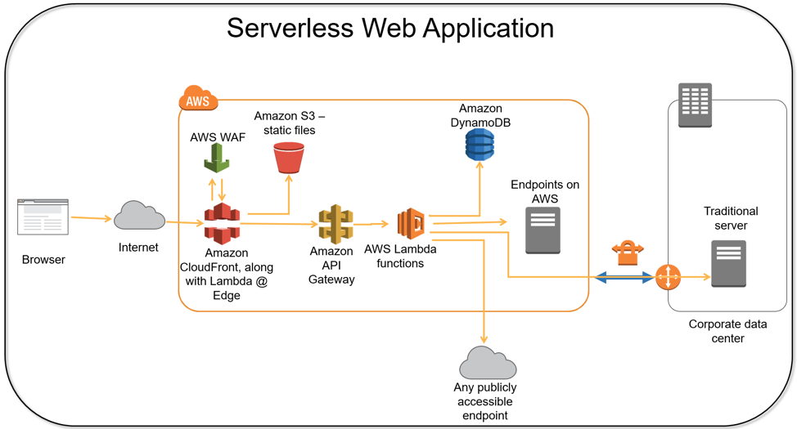
Building serverless applications means that your developers can focus on their core product instead of worrying about managing and operating servers or runtimes, either in the cloud or on-premises. This reduced overhead lets developers reclaim time and energy that can be spent on developing great products which scale and that are reliable.
Therefore, the correct answer is Serverless removes management overhead so you can focus on your applications instead.
You get overall cheaper costs compared to using non-serverless services is incorrect since using serverless does not always guarantee cheaper costs. There might be instances where serverless can be more expensive for your setup, such as workloads with long processing durations and high memory usages.
Serverless are highly available so you don’t have to worry about downtime is incorrect. Although in most occasions serverless does not experience downtime, you should still create failover solutions for your critical applications. Serverless, essentially, still uses servers in the background. The benefit you get from serverless is that you won’t have to worry about server management anymore. So it is a good practice to always have a fail-safe plan.
Security is fully managed for you by the service provider is incorrect. Security is not fully managed for you when using serverless. Always go back to the AWS shared responsibility model to know which security responsibilities are yours and which ones are AWS’.

Reference:
https://aws.amazon.com/serverless/

36. QUESTION
Category: CCP – Cloud Technology and Services
A company needs to simplify the migration of its databases from an on-premises server to AWS. Which service fits best for this purpose?
- AWS Snowball
- AWS Snowmobile
- AWS Database Migration Service (Correct)
- AWS Application Migration Service

AWS Database Migration Service helps you migrate databases to AWS quickly and securely. The source database remains fully operational during the migration, minimizing downtime to applications that rely on the database. The AWS Database Migration Service can migrate your data to and from most widely used commercial and open-source databases.
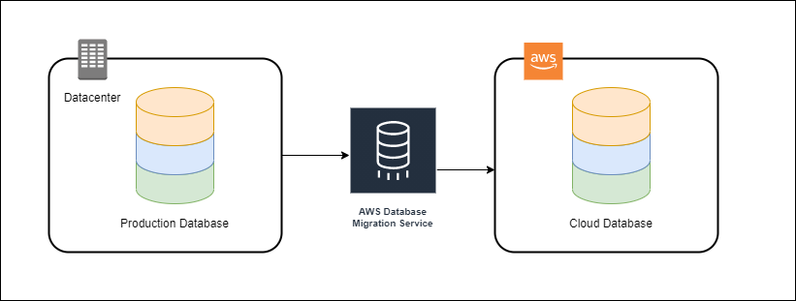
In homogeneous database migrations, the source and target database engines are the same or are compatible like Oracle to Amazon RDS for Oracle, MySQL to Amazon Aurora, MySQL to Amazon RDS for MySQL, or Microsoft SQL Server to Amazon RDS for SQL Server. Since the schema structure, data types, and database code are compatible between the source and target databases, this kind of migration is a one-step process.
A company can create a migration task with connections to the source and target databases, then start the migration with the click of a button. AWS Database Migration Service takes care of the rest. The source database can be located in the company’s on-premises outside of AWS, running on an Amazon EC2 instance, or it can be an Amazon RDS database. The target can be a database in Amazon EC2 or Amazon RDS.
Hence, the correct answer is AWS Database Migration Service.
AWS Application Migration Service is incorrect because this tool is primarily used for migrating applications from virtual, cloud, and physical servers to AWS. While it can be used for database migrations, its primary focus is on applications, which includes the entirety of the software stack. For migrations specifically focusing on databases, AWS Database Migration Service is a more suitable fit.
AWS Snowball and AWS Snowmobile are both incorrect because these are just migration services that allow you to transfer large amounts of data from your on-premises data center to Amazon S3. These tools are not meant to transfer databases.

References:
https://aws.amazon.com/dms/
https://docs.aws.amazon.com/dms/latest/userguide/Welcome.html

Check out this AWS Database Migration Service Cheat Sheet:
https://tutorialsdojo.com/aws-database-migration-service/

37. QUESTION
Category: CCP – Security and Compliance
Which of the following is needed to retrieve a list of your EC2 instances using the AWS CLI?
- SSH keys
- Access Keys (Correct)
- Username and password
- MFA

The AWS Access Key ID and AWS Secret Access Key are your AWS credentials. They are associated with an AWS Identity and Access Management (IAM) user or role that determines what permissions you have.
Access keys are long-term credentials for an IAM user or the AWS account root user. You can use access keys to sign programmatic requests to the AWS CLI or AWS API (directly or using the AWS SDK). If you don’t have access keys, you can create them from the AWS Management Console. As a best practice, do not use the AWS account root user access keys for any task where it’s not required. Instead, create a new administrator IAM user with access keys for yourself.
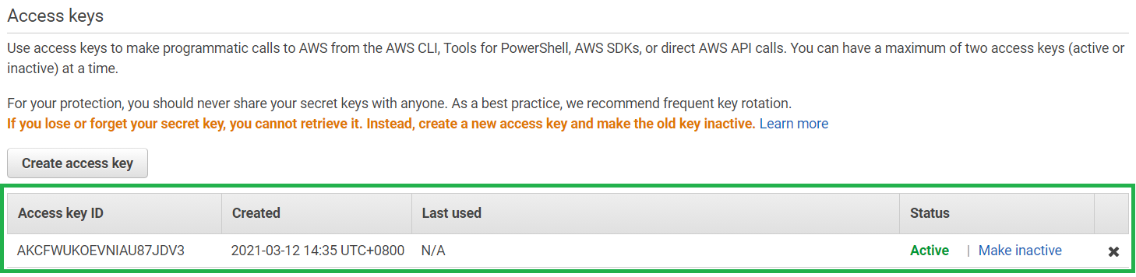
Like a user name and password, you must use both the access key ID and secret access key together to authenticate your requests. You can use this on your AWS CLI to access your AWS resources.
Hence, the correct answer is: Access keys.
Username and password is incorrect because it is stated in the question that the action is done through the AWS CLI.
MFA is not required when using the AWS CLI.
SSH keys is incorrect because this is primarily used to authenticate your SSH connection to an EC2 instance. For this question, these keys are not needed by the AWS CLI.

References:
https://docs.aws.amazon.com/IAM/latest/UserGuide/id_credentials_access-keys.html
https://docs.aws.amazon.com/general/latest/gr/aws-sec-cred-types.html

Check out this AWS IAM Cheat Sheet:
https://tutorialsdojo.com/aws-identity-and-access-management-iam/

38. QUESTION
Category: CCP – Cloud Technology and Services
Which business intelligence tool is offered by Amazon Web Services and allows users to create and publish interactive dashboards and reports easily?
- AWS Cost and Usage Report
- AWS Trusted Advisor
- Amazon QuickSight (Correct)
- AWS Cost Explorer

Amazon QuickSight is an Amazon Web Services business intelligence service that allows users to create and publish interactive dashboards and reports. Amazon QuickSight is intended to empower consumers with varying degrees of technical skill with simple-to-use and sophisticated visualization features. Users can connect to various data sources using Amazon QuickSight, including AWS data services, SaaS apps, and on-premises databases. The service incorporates complex capabilities such as forecasting, trend analysis, and various display formats such as charts, tables, and graphs. QuickSight interfaces with other AWS services like AWS Lambda and Amazon S3 to allow customers to create unique data pipelines.
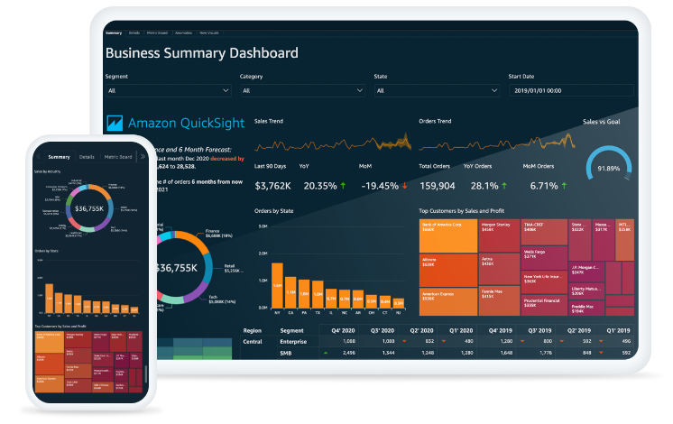
Scalability and cost-effectiveness are two of Amazon QuickSight’s primary advantages. The service is scalable and can handle data sets ranging from a few kilobytes to petabytes. Furthermore, QuickSight has a pay-per-session pricing approach, meaning that users are only charged for the sessions they utilize the service. This makes it appealing to organizations of all sizes because they pay for what they use and do not need to make substantial upfront investments in hardware or software. Overall, Amazon QuickSight is a powerful and flexible business intelligence tool that can help organizations to gain insights into their data and make informed decisions based on those insights.
Hence the correct answer is: Amazon QuickSight.
AWS Cost Explorer is incorrect because it is a service that allows users to visualize and analyze their AWS costs and usage data.
AWS Cost and Usage Report is incorrect because it provides a comprehensive report of the AWS usage and associated costs incurred by an AWS account.
AWS Trusted Advisor is incorrect because it provides real-time guidance to help customers optimize their AWS infrastructure for security, cost optimization, and performance.
References:
https://aws.amazon.com/quicksight/pricing/
https://docs.aws.amazon.com/quicksight/
Check out this Amazon QuickSight:
https://tutorialsdojo.com/amazon-quicksight/

39. QUESTION
Category: CCP – Security and Compliance
Which of the following statements is true for AWS CloudTrail?
- CloudTrail is able to capture application error logs from your EC2 instances
- When you create a trail in the AWS Management Console, the trail applies to all AWS Regions by default (Correct)
- CloudTrail charges you for every management event trail created
- CloudTrail is disabled by default for newly created AWS accounts

AWS CloudTrail is a service that enables governance, compliance, operational auditing, and risk auditing of your AWS account. With CloudTrail, you can log, continuously monitor, and retain account activity related to actions across your AWS infrastructure. CloudTrail provides the event history of your AWS account activity, including actions taken through the AWS Management Console, AWS SDKs, command-line tools, and other AWS services. This event history simplifies security analysis, resource change tracking, and troubleshooting.
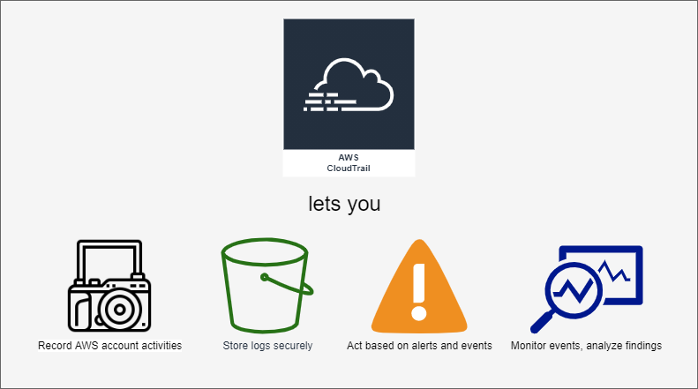
With AWS CloudTrail, simplify your compliance audits by automatically recording and storing event logs for actions made within your AWS account. Integration with Amazon CloudWatch Logs provides a convenient way to search through log data, identify out-of-compliance events, accelerate incident investigations, and expedite responses to auditor requests. After creating a trail, by default, it is applied to all AWS Regions. Alternatively, you can also specify the trail to only a specific Region if you wish to.
Hence, the correct answer is: When you create a trail in the AWS Management Console, the trail applies to all AWS Regions by default.
The option that says: CloudTrail is disabled by default for newly created AWS accounts is incorrect because AWS CloudTrail is now enabled by default for ALL CUSTOMERS and will provide visibility into the past seven days of account activity without the need for you to configure a trail in the service to get started.
The option that says: CloudTrail is able to capture application error logs from your EC2 is incorrect because CloudTrail actually does not capture error logs in your EC2 instances. You may instead use CloudWatch Logs for this purpose.
The option that says: CloudTrail charges you for every management event trail created is incorrect because actually, CloudTrail does not charge you for your first management trail, but only the additional management trails you create after the first one.

References:
https://aws.amazon.com/cloudtrail/
https://aws.amazon.com/cloudtrail/pricing/
https://docs.aws.amazon.com/awscloudtrail/latest/userguide/cloudtrail-create-a-trail-using-the-console-first-time.html

40. QUESTION
Category: CCP – Cloud Concepts
Which of the following are advantages of Cloud Computing? (Select TWO.)
- Increase speed and agility. (Correct)
- Trade capital expense for variable expense. (Correct)
- Massive discounts for your computers, network devices and other equipment from Amazon online shopping website.
- Trade variable expense for capital expense.
- Achieve lower economies of scale.

Cloud computing is the on-demand delivery of compute power, database, storage, applications, and other IT resources via the internet with pay-as-you-go pricing.
Whether you are using it to run applications that share photos to millions of mobile users or to support business critical operations, a cloud services platform provides rapid access to flexible and low cost IT resources. With cloud computing, you don’t need to make large upfront investments in hardware and spend a lot of time on the heavy lifting of managing that hardware. Instead, you can provision exactly the right type and size of computing resources you need to power your newest idea or operate your IT department. You can access as many resources as you need, almost instantly, and only pay for what you use.
There are six advantages of using Cloud Computing:
1. Trade capital expense for variable expense
– Instead of having to invest heavily in data centers and servers before you know how you’re going to use them, you can pay only when you consume computing resources, and pay only for how much you consume.
2. Benefit from massive economies of scale
– By using cloud computing, you can achieve a lower variable cost than you can get on your own. Because usage from hundreds of thousands of customers is aggregated in the cloud, providers such as AWS can achieve higher economies of scale, which translates into lower pay as-you-go prices.
3. Stop guessing capacity
– Eliminate guessing on your infrastructure capacity needs. When you make a capacity decision prior to deploying an application, you often end up either sitting on expensive idle resources or dealing with limited capacity. With cloud computing, these problems go away. You can access as much or as little capacity as you need, and scale up and down as required with only a few minutes’ notice.
4. Increase speed and agility
– In a cloud computing environment, new IT resources are only a click away, which means that you reduce the time to make those resources available to your developers from weeks to just minutes. This results in a dramatic increase in agility for the organization, since the cost and time it takes to experiment and develop is significantly lower.
5. Stop spending money running and maintaining data centers
– Focus on projects that differentiate your business, not the infrastructure. Cloud computing lets you focus on your own customers, rather than on the heavy lifting of racking, stacking, and powering servers.
6. Go global in minutes
– Easily deploy your application in multiple regions around the world with just a few clicks. This means you can provide lower latency and a better experience for your customers at minimal cost.
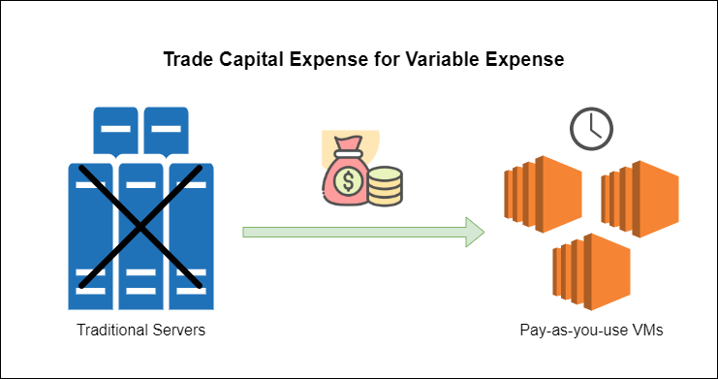
Hence, the correct answers are Trade capital expense for variable expense and Increase speed and agility.
The option that says: Trade variable expense for capital expense is incorrect because it should be the other way around. One of the advantages of Cloud Computing is the opportunity to trade capital expense for variable expense.
The option that says: Achieve lower economies of scale is incorrect because this is actually the opposite. By using cloud computing, you can achieve a lower variable cost than you can get on your own through the massive economies of scale.
The option that says: Massive discounts for your computers, network devices and other equipment from Amazon online shopping website is incorrect because the Amazon.com platform is different from its Amazon Web Services cloud computing division. Discounts from purchasing computer hardware is not an advantage of cloud computing.

References:
https://docs.aws.amazon.com/whitepapers/latest/aws-overview/six-advantages-of-cloud-computing.html
https://d1.awsstatic.com/whitepapers/aws-overview.pdf

Check out our Tutorials Dojo AWS Cheat Sheets:
https://tutorialsdojo.com/aws-cheat-sheets/
41. QUESTION
Category: CCP – Security and Compliance
Which of the following security group rules are valid? (Select TWO.)
- Inbound RDP rule with an address range as source (Correct)
- Outbound HTTPS rule with hostname as destination
- Outbound MYSQL rule with IP address as source
- Inbound HTTP rule with security group ID as source (Correct)
- Inbound TCP rule with instance ID as source

Security groups accept IP address, IP address range, and security group ID as either source or destination of inbound or outbound rules. Below is an example of what these rules may look like.
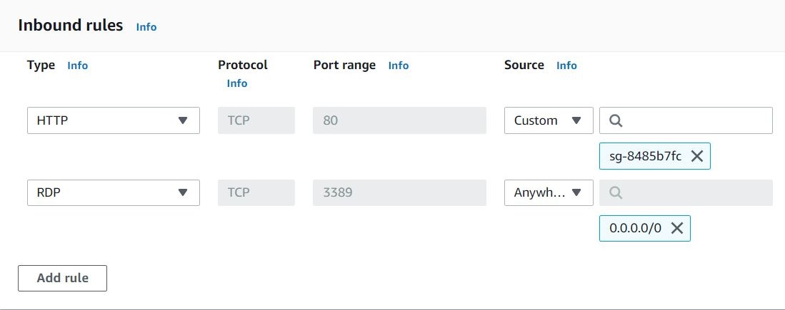
Hence, the correct answers are: Inbound HTTP rule with security group ID as source and Inbound RDP rule with an address range as source.
Inbound TCP rule with instance ID as source and Outbound HTTPS rule with hostname as destination are both incorrect because Instance IDs or hostnames are not valid values.
Outbound MYSQL rule with IP address as source is incorrect because the source cannot be modified. Since it is outbound, you should specify the allowed destination instead.
Reference:
https://docs.aws.amazon.com/vpc/latest/userguide/VPC_SecurityGroups.html
Check out these Tutorials Dojo Cheat Sheets:
https://tutorialsdojo.com/security-group-vs-nacl/
https://tutorialsdojo.com/amazon-elastic-compute-cloud-amazon-ec2/

42. QUESTION
Category: CCP – Cloud Technology and Services
A company decided to migrate its operation to the AWS Cloud by leveraging on the different AWS Cloud Adoption Framework (AWS CAF) perspectives to identify capability gaps and cross-organizational dependencies.
Which phase of the cloud transformation journey do these plans belong to?
- Launch
- Scale
- Align (Correct)
- Envision

The AWS Cloud Adoption Framework (AWS CAF) leverages AWS experience and best practices to help you digitally transform and accelerate your business outcomes through innovative use of AWS. AWS CAF identifies specific organizational capabilities that underpin successful cloud transformations. Use the AWS CAF to identify and prioritize transformation opportunities, evaluate and improve your cloud readiness, and iteratively evolve your transformation roadmap.
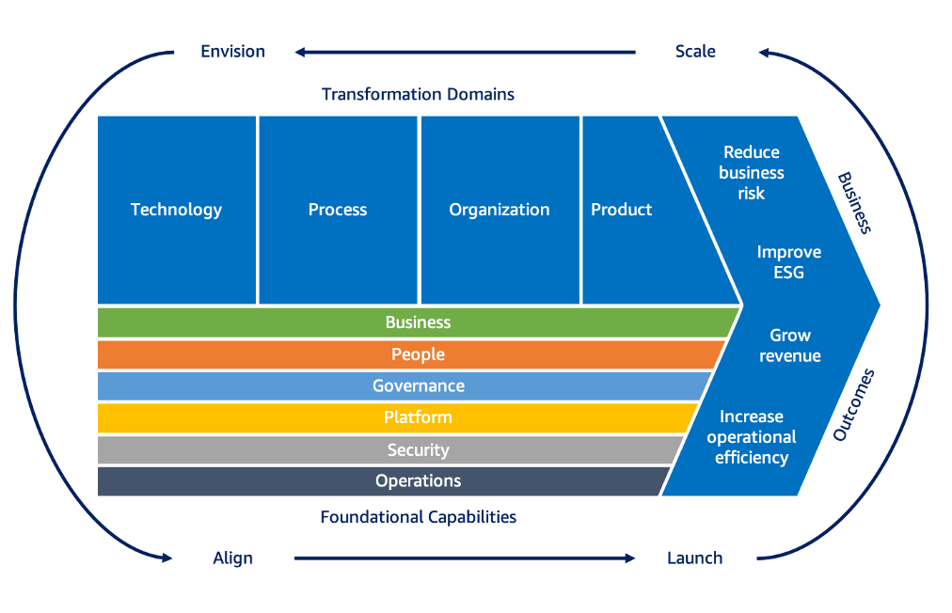
Adopting an iterative approach will help you maintain momentum and evolve your roadmap as you learn from experience. Adopting an iterative approach will help you maintain momentum and evolve your roadmap as you learn from experience. The AWS CAF recommends four iterative and incremental cloud transformation phases:
– Envision
– Align
– Scale
– Launch
The Align phase focuses on identifying capability gaps across the six AWS CAF perspectives, identifying cross-organizational dependencies, and surfacing stakeholder concerns and challenges. Doing so will help you create strategies for improving your cloud readiness, ensure stakeholder alignment, and facilitate relevant organizational change management activities.
Hence, the correct answer is Align.
Envision is incorrect because its primary purpose is to identify measurable business outcomes that will help the business progress during the transformation journey.
Launch is incorrect because this phase is simply delivering pilots in production and demonstrating incremental business value rather than identifying capability gaps.
Scale is incorrect because this one only focuses on expanding pilots and business value to the desired scale of your company, as well as ensuring the realization and sustainability of cloud-related business benefits. It doesn’t include identifying capability gaps.

References:
https://aws.amazon.com/cloud-adoption-framework/
https://docs.aws.amazon.com/whitepapers/latest/overview-aws-cloud-adoption-framework/your-cloud-transformation-journey.html

Check out this AWS Cloud Adoption Framework:
https://tutorialsdojo.com/aws-cloud-adoption-framework-aws-caf/

43. QUESTION
Category: CCP – Security and Compliance
AWS Identity and Access Management (IAM) enables you to manage access to AWS services and resources securely. Which of the following best describes what an account alias is in IAM?
- The numerical value of your account ID
- Your IAM root username
- A substitute for an account ID in the web address for your account (Correct)
- The name AWS assigns to your account

An account alias substitutes for an account ID in the web address for your account. You can create and manage an account alias from the AWS Management Console, AWS CLI, or AWS API. You use an account alias when you prefer to use a more user-friendly account name rather than the long string of numbers.
For example, you have the following account ID: 403299380220
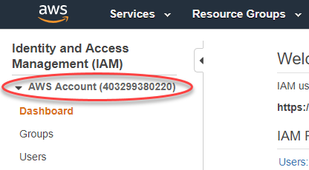
By default, your sign-in page URL is this:
https://403299380220.signin.aws.amazon.com/console
If you create an AWS account alias for your AWS account ID, say tutorialsdojo, your sign-in page URL looks like the following example:
https://tutorialsdojo.signin.aws.amazon.com/console
Hence, the correct answer is A substitute for an account ID in the web address for your account.
The other options incorrectly describe what an account alias is.

References:
https://docs.aws.amazon.com/IAM/latest/UserGuide/console_account-alias.html
https://docs.aws.amazon.com/IAM/latest/UserGuide/console.html

Check out this AWS IAM Cheat Sheet:
https://tutorialsdojo.com/aws-identity-and-access-management-iam/

44. QUESTION
Category: CCP – Cloud Concepts
A manufacturing company is undergoing an organizational transformation to focus more on its customers, aiming to maximize the value delivered to them. This shift involves promoting team collaboration to ensure alignment with the firm’s strategic objectives.
How can the company achieve this goal while following the AWS Cloud Adoption Framework (CAF)? (Choose two.)
- Restructure teams to prioritize product-focused and value stream-oriented approaches. (Correct)
- Employ a robust data and analytics platform to generate actionable insights.
- Transition and upgrade legacy infrastructure through migration and modernization efforts.
- Introduce new products and revenue models.
- Adopt agile methodologies for continuous improvement and rapid innovation. (Correct)

In today’s rapidly evolving business landscape, organizations constantly seek ways to stay ahead of the competition and unlock new growth opportunities. One powerful approach to achieve this is through the cloud-powered digital transformation of business processes, and a framework that facilitates this transformation is the AWS Cloud Adoption Framework (CAF) and its Cloud Transformation Value Chain.
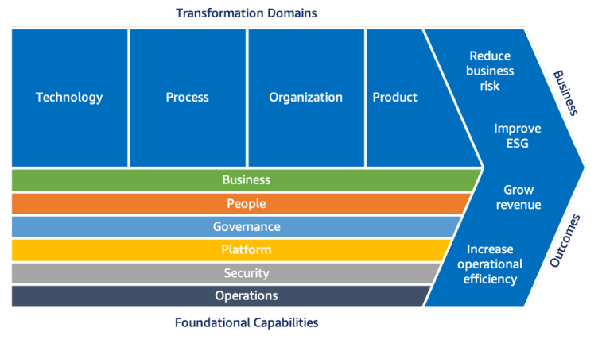
The AWS CAF provides comprehensive guidelines, best practices, and tools to help organizations plan, execute, and manage their cloud adoption journey. It serves as a roadmap for businesses to navigate the complexities of digital transformation and leverage the full potential of cloud computing services offered by AWS. Cloud Transformation Value Chain has four key areas that must be addressed for a successful digital transformation, which are the following:
– Technological transformation involves using the power of cloud computing to optimize and modernize existing IT infrastructure. It enables businesses to quickly adapt to changing market demands, scale resources on demand, and reduce operational complexities.
– Process transformation focuses on reimagining and optimizing business processes to utilize cloud-native capabilities. By embracing cloud-native tools and services, organizations can automate repetitive tasks, improve collaboration and communication, and accelerate time-to-market for new products and services.
– Organizational transformation entails reshaping an organization’s culture, structure, and skills to support cloud-powered digital transformation. This involves fostering a cloud-first mindset, establishing new roles and responsibilities, and upskilling employees to work effectively in the cloud environment. By embracing a culture of innovation and agility, organizations can enable faster decision-making, promote cross-functional collaboration, and drive continuous improvement.
– Product transformation uses cloud capabilities to innovate and deliver new digital products and services. This transformation enables businesses to enhance customer experiences, explore new revenue streams, and gain a competitive advantage in the market.
Restructuring teams to prioritize product-focused and value stream-oriented approaches emphasizes the importance of organizing teams around specific products or value streams. By doing so, the company can foster collaboration among team members who are responsible for delivering value to customers. This approach encourages cross-functional cooperation and ensures that teams are aligned with the firm’s strategic objectives.
Adopting agile methodologies, on the other hand, promote iterative development, frequent customer feedback, and continuous improvement. By adopting agile practices, the company can respond quickly to customer needs, adapt to changing market conditions, and continuously deliver value.
Hence the correct answers are:
– Restructure teams to prioritize product-focused and value stream-oriented approaches.
– Adopt agile methodologies for continuous improvement and rapid innovation.
The option that says: Transition and upgrade legacy infrastructure through migration and modernization efforts is incorrect. While transitioning and upgrading legacy infrastructure can be beneficial for optimizing operations and improving product quality, it does not directly address the goal of increasing agility and responsiveness to customer needs. It focuses more on the technical components of infrastructure.
The option that says: Employ a robust data and analytics platform to generate actionable insights is incorrect. Employing a data and analytics platform is indeed valuable for generating actionable insights. However, while it can provide helpful insight, it is not directly tied to optimizing operations and delivery processes or enhancing agility and responsiveness.
The option that says: Introduce new products and revenue models is incorrect. This option focuses more on innovation and expanding the company’s offerings rather than promoting team collaboration and a customer-centric approach.

References:
https://docs.aws.amazon.com/pdfs/whitepapers/latest/overview-aws-cloud-adoption-framework/overview-aws-cloud-adoption-framework.pdf
https://aws.amazon.com/cloud-adoption-framework/

45. QUESTION
Category: CCP – Security and Compliance
What is the best way to keep track of all activities made in your AWS account?
- Set up MFA logging to know who is currently in your environment
- Use LDAP authentication on your AWS account
- Use Amazon CloudWatch Logs to log all activities
- Create a multi-region trail in AWS CloudTrail (Correct)

AWS CloudTrail is a service that enables governance, compliance, operational auditing, and risk auditing of your AWS account. With CloudTrail, you can log, continuously monitor, and retain account activity related to actions across your AWS infrastructure. CloudTrail provides event history of your AWS account activity, including actions taken through the AWS Management Console, AWS SDKs, command line tools, and other AWS services. Creating a multi-region trail will allow you to keep your activity records in an S3 bucket and prevent them from getting rewritten automatically.

Hence, the correct answer is: Create a multi-region trail in AWS CloudTrail.
Using Amazon Cloudwatch Logs is incorrect since this service is not related to user actions in your account. CloudWatch Logs enables you to centralize the logs from all of your systems, applications, and AWS services that you use, in a single, highly scalable service.
Setting up MFA is incorrect because it will not tell you exactly who performed what in your AWS account.
Using LDAP authentication on your AWS account is incorrect because not all company supports it. Access logging can be done from the company’s side however, this cannot capture the actions performed within the AWS account.

Reference:
https://aws.amazon.com/cloudtrail/

Check out this AWS CloudTrail Cheat Sheet:
https://tutorialsdojo.com/aws-cloudtrail/

46. QUESTION
Category: CCP – Billing, Pricing and Support
Among the following payment options, which of the following can you choose when you purchase a Standard or Convertible Reserved Instance? (Select TWO.)
- Deferred payment
- All Upfront payment (Correct)
- Reserved payment
- Partial upfront payment (Correct)
- Bill-Me-Later payment

Reserved Instances provide you with a significant discount compared to On-Demand instance pricing. In addition, when Reserved Instances are assigned to a specific Availability Zone, they provide a capacity reservation, giving you additional confidence in your ability to launch instances when you need them.
You can choose between three payment options when you purchase a Standard or Convertible Reserved Instance:
All Upfront option: You pay for the entire Reserved Instance term with one upfront payment. This option provides you with the largest discount compared to On-Demand instance pricing.
Partial Upfront option: You make a low upfront payment and are then charged a discounted hourly rate for the instance for the duration of the Reserved Instance term.
No Upfront option: Does not require any upfront payment and provides a discounted hourly rate for the duration of the term.
As a general rule, Standard RI provides more savings than Convertible RI, which means that the former is the cost-effective option. The All Upfront option provides you with the largest discount compared with the other types. Opting for a longer compute reservation, such as the 3-year term, gives us greater discount as opposed to a shorter 1-year renewable term.
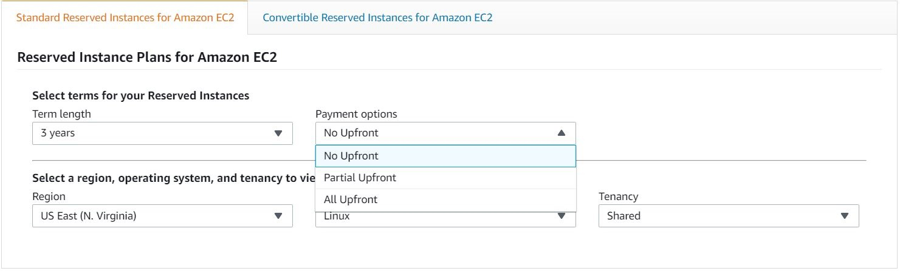
Hence, the correct answers are: All Upfront payment and Partial upfront payment.
Deferred payment, Reserved payment and Bill-Me-Later payment are all incorrect because these pricing constructs are not supported in Reserved Instances.

References:
https://aws.amazon.com/ec2/pricing/reserved-instances/pricing/
https://docs.aws.amazon.com/AWSEC2/latest/UserGuide/ec2-reserved-instances.html
47. QUESTION
Category: CCP – Cloud Technology and Services
In which of the following occasions should you use the Amazon SQS in your application system? (Select TWO.)
- If you require a durable storage for your application events or messages (Correct)
- If you need to decouple certain parts of your system for better fault tolerance (Correct)
- When your application requires the use of industry-standard messaging protocols for message delivery
- When you have to automate certain tasks in your workflow
- If you need to submit push notifications to your event subscribers

Use Amazon SQS to transmit any volume of data, at any level of throughput, without losing messages or requiring other services to be available. SQS lets you decouple application components so that they run and fail independently, increasing the overall fault tolerance of the system. Multiple copies of every message are stored redundantly across multiple availability zones so that they are available whenever needed.
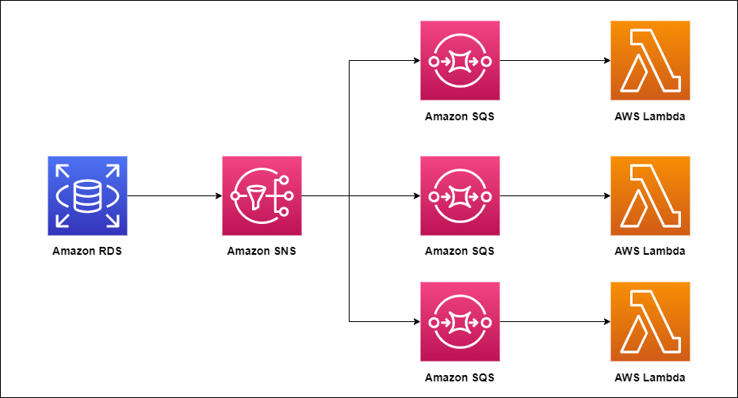
Hence, the correct answers:
– If you need to decouple certain parts of your system for better fault tolerance
– If you require a durable storage for your application events or messages
If you need to submit push notifications to your event subscribers is incorrect. If you need to submit push notifications, you should use Amazon SNS instead.
When you have to automate certain tasks in your workflow is incorrect. If you need to automate certain workflows in AWS, you should use Amazon SWF.
When your application requires the use of industry-standard messaging protocols for message delivery is incorrect. If your messaging service requires the use of certain protocols, try using Amazon MQ.
References:
https://aws.amazon.com/sqs/
https://aws.amazon.com/message-queue/benefits/
Check out this Amazon SQS Cheat Sheet:
https://tutorialsdojo.com/amazon-sqs/

48. QUESTION
Category: CCP – Cloud Concepts
The use of multi-threading in your Amazon S3 requests via the Multipart Upload API is an example of which AWS cloud best practice?
- Think parallel. (Correct)
- Allow for evolutionary architectures.
- Implement elasticity.
- Decouple your components.

There are various best practices that you can follow which can help you build an application in the cloud. The notable ones are:
1. Design for failure
2. Decouple your components
3. Implement elasticity
4. Think parallel
As the name implies, the Think Parallel best practice accentuates the use of parallelization when designing architectures in the AWS cloud. It is advisable to not only implement parallelization wherever possible but also automate it because the cloud allows you to create a repeatable process very easily.
When it comes to accessing (retrieving and storing) data, the cloud is designed to handle massively parallel operations. In order to achieve maximum performance and throughput, you should leverage request parallelization. Multi-threading your requests by using multiple concurrent threads will store or fetch the data faster than requesting it sequentially. Hence, wherever possible, the processes of a cloud application should be made thread-safe through a share-nothing philosophy and leverage multi-threading.

When it comes to processing or executing requests in the cloud, it becomes even more important to leverage parallelization. A general best practice, in the case of a web application, is to distribute the incoming requests across multiple asynchronous web servers using a load balancer. In the case of batch processing applications, your master node can spawn up multiple slave worker nodes that process tasks in parallel (as in distributed processing frameworks like Hadoop).
The AWS-specific tactics for parallelization are:
1. Multi-thread your Amazon S3 requests as detailed in the best practices paper.
2. Multi-thread your Amazon SimpleDB GET and BATCHPUT requests.
3. Create a JobFlow using the Amazon Elastic MapReduce Service for each of your daily batch processes (indexing, log analysis, etc.) which will compute the job in parallel and save time.
4. Use the Elastic Load Balancing service and spread your load across multiple web app servers dynamically.
Hence, the correct answer is: Think Parallel.
Decouple your components is incorrect because this principle simply reinforces the Service-Oriented Architecture (SOA) design principle that the more loosely coupled the components of the system, the bigger and better it scales. This can be implemented by using Amazon SQS to isolate components and act as a buffer between them.
Implement elasticity is incorrect because this principle is primarily implemented by automating your deployment process and streamlining the configuration and build process of your architecture. This ensures that the system can scale without any human intervention.
Allow evolutionary architectures is incorrect because this is actually one of the general design principles of the AWS Well-Architected Framework and not particularly a type of cloud best practice.

References:
https://d1.awsstatic.com/whitepapers/AmazonS3BestPractices.pdf
https://wa.aws.amazon.com/wat.design_principles.wa-dp.en.html

Check out this AWS Well-Architected Framework Cheat Sheet:
https://tutorialsdojo.com/aws-well-architected-framework-design-principles/

49. QUESTION
Category: CCP – Cloud Technology and Services
A Cloud Architect in a large e-commerce company manages the company’s AWS environment. One day, the Cloud Architect was notified that one of their EC2 instances had been running non-stop for over 30 days, and its usage costs had skyrocketed. The Cloud Architect needs to identify the root cause of the issue and find a way to reduce the usage costs of the instance.
Which of the following AWS services can help the Cloud Architect identify the issue and check if their running resources conform to AWS best practices?
- AWS Trusted Advisor (Correct)
- Amazon CloudWatch
- AWS IAM
- AWS Config

AWS Trusted Advisor is an application that draws upon best practices learned from AWS’ aggregated operational history of serving hundreds of thousands of AWS customers. Trusted Advisor inspects your AWS environment and makes recommendations for saving money, improving system performance, or closing security gaps.
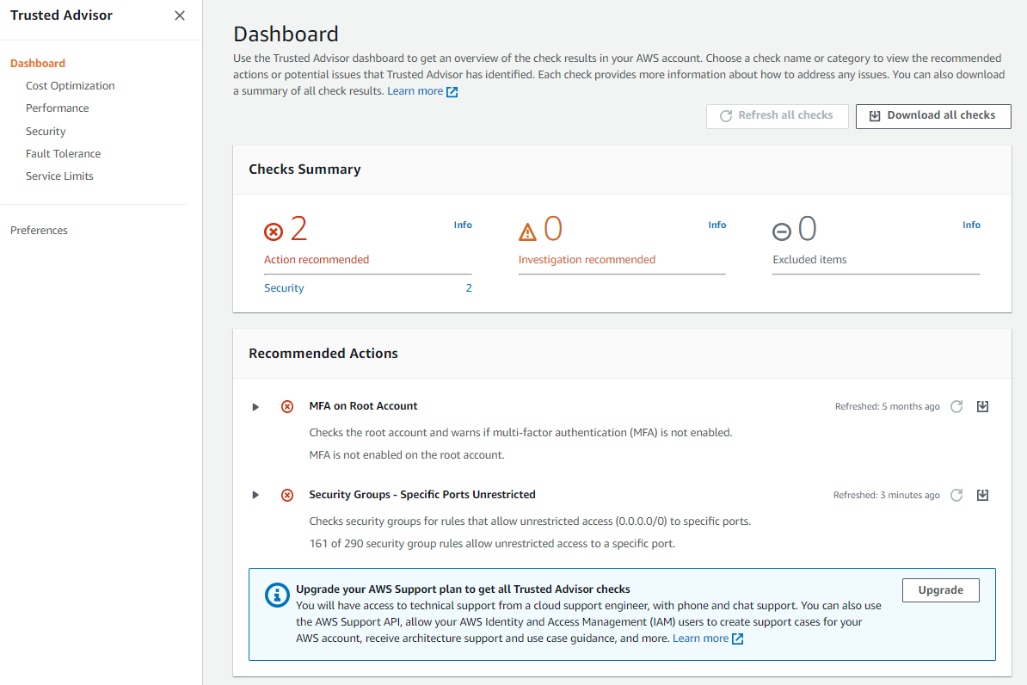
Trusted Advisor includes an ever-expanding list of checks in the following five categories:
Cost Optimization – recommendations that can potentially save you money by highlighting unused resources and opportunities to reduce your bill.
Security – identification of security settings that could make your AWS solution less secure.
Fault Tolerance – recommendations that help increase the resiliency of your AWS solution by highlighting redundancy shortfalls, current service limits, and over-utilized resources.
Performance – recommendations that can help to improve the speed and responsiveness of your applications.
Service Limits – recommendations that will tell you when service usage is more than 80% of the service limit.
Hence, the correct answer is AWS Trusted Advisor.
Amazon CloudWatch is incorrect because this simply provides you with data and actionable insights to monitor your applications, respond to system-wide performance changes, optimize resource utilization, and get a unified view of operational health. CloudWatch collects monitoring and operational data in the form of logs, metrics, and events, providing you with a unified view of AWS resources, applications, and services that run on AWS and on-premises servers. It does not check whether your resources conform with the best practices.
AWS Config is incorrect because this is just a compliance monitoring tool. It makes sure your resources are in line with your set guidelines and requirements.
AWS IAM is incorrect because this is simply a security service used to manage your accounts and user permissions. It does not check whether your resources conform to the best practices.

References:
https://aws.amazon.com/premiumsupport/technology/trusted-advisor/
https://aws.amazon.com/premiumsupport/technology/trusted-advisor/faqs/

Check out this AWS Trusted Advisor Cheat Sheet:
https://tutorialsdojo.com/aws-trusted-advisor/

50. QUESTION
Category: CCP – Cloud Technology and Services
Which of the following services allows you to store Docker images and orchestrate Docker containers in a simple and cost-effective manner? (Select TWO.)
- Amazon ECR (Correct)
- AWS Batch
- AWS CodeCommit
- AWS Lambda
- Amazon ECS (Correct)

Amazon Elastic Container Service (Amazon ECS) is a highly scalable, high-performance container orchestration service that supports Docker containers and allows you to easily run and scale containerized applications on AWS.
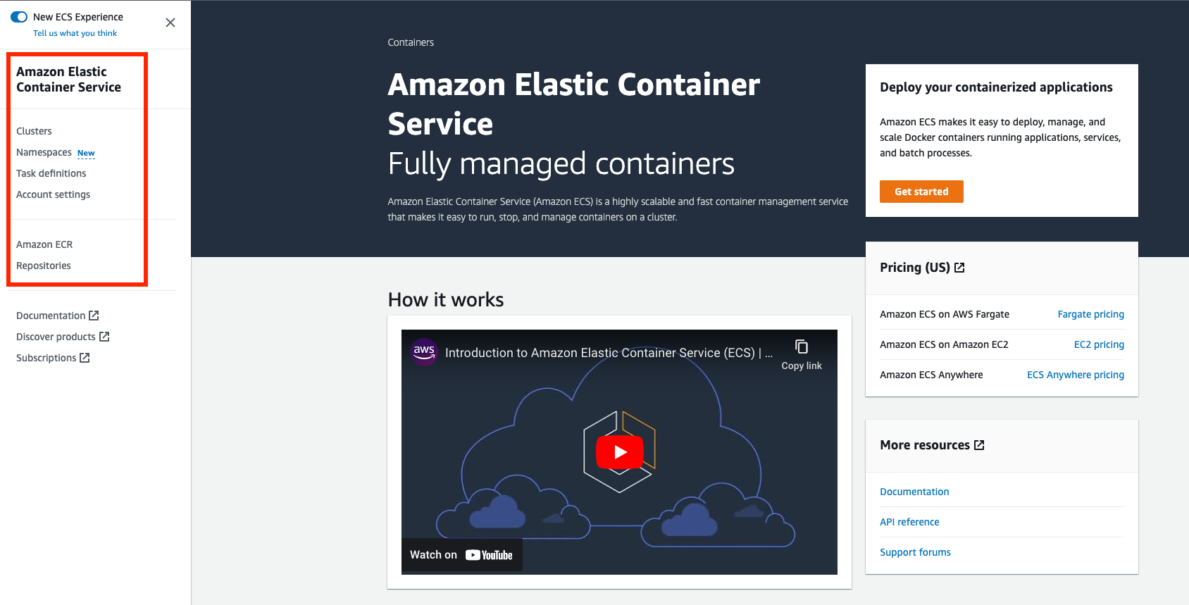
Amazon Elastic Container Registry (ECR) is a fully-managed Docker container registry that makes it easy for developers to store, manage, and deploy Docker container images. Amazon ECR is integrated with Amazon Elastic Container Service (ECS), simplifying your development to production workflow.
Hence, the correct answers are:
– Amazon ECR
– Amazon ECS
AWS Lambda is incorrect since this is a serverless compute service of AWS. It does not handle containers.
AWS CodeCommit is incorrect since this is a fully-managed source control service that hosts secure Git-based repositories. It makes it easy for teams to collaborate on code in a secure and highly scalable ecosystem.
AWS Batch is incorrect since this is a compute service that is used to run hundreds of thousands of batch computing jobs on AWS. It is not used for Docker container orchestration or Docker image repository.

References:
https://aws.amazon.com/ecr/
https://aws.amazon.com/ecs/

Check out these Tutorials Dojo Cheat Sheets:
https://tutorialsdojo.com/amazon-elastic-container-registry-amazon-ecr/
https://tutorialsdojo.com/amazon-elastic-container-service-amazon-ecs/

51. QUESTION
Category: CCP – Billing, Pricing and Support
Which of the following is true about the enhanced technical support response times of the Enterprise support plan in AWS? (Select TWO.)
- Provides a 15-minute response time support if your business-critical system goes down (Correct)
- Provides a 2-hour response time support if your production system got impaired
- Provides a 12-hour response time support for general guidance
- Provides a 1-hour response time support if your production system goes down (Correct)
- Provides a 48-hour response time support for general guidance

AWS Enterprise Support provides you with a concierge-like service where the main focus is helping you achieve your outcomes and find success in the cloud.
With Enterprise Support, you get 24×7 technical support from high-quality engineers, tools, and technology to automatically manage the health of your environment, consultative architectural guidance delivered in the context of your applications and use-cases, and a designated Technical Account Manager (TAM) to coordinate access to proactive/preventative programs and AWS subject matter experts.

The AWS Enterprise support plan has enhanced technical support which provides 24×7 access to Cloud Support Engineers via phone, chat, and email. You can have an unlimited number of contacts that can open an unlimited amount of cases.
Hence, the correct answers are:
– Provides a 15-minute response time support if your business-critical system goes down.
– Provides a 1-hour response time support if your production system goes down.
The option that says: Provides a 2-hour response time support if your production system got impaired is incorrect because the Enterprise support plan actually provides you with a 4-hour response time if your system in production got impaired.
The option that says: Provides a 12-hour response time support for general guidance is incorrect because this support plan actually provides a 24-hour response time and not within 12 hours.
The option that says: Provides a 48-hour response time support for general guidance is incorrect because just as mentioned above, the Enterprise Support Plan has a 24-hour response time.

References:
https://aws.amazon.com/premiumsupport/plans/
https://docs.aws.amazon.com/awssupport/latest/user/getting-started.html
https://aws.amazon.com/premiumsupport/plans/enterprise/

Check out this AWS Support Plans Cheat Sheet:
https://tutorialsdojo.com/aws-support-plans/

52. QUESTION
Category: CCP – Billing, Pricing and Support
A company intends to utilize Amazon EC2 instances and AWS Lambda functions as their primary compute resources in the long term. The company wants to use these compute resources for at least 3 years at the cheapest cost.
Which AWS purchasing options would optimize the company’s computing costs?
- Spot Instances
- Reserved Instances
- Computer Savings Plans (Correct)
- Dedicated Hosts

Savings Plans is an offering of AWS that grants a flexible pricing model for those customers who want to significantly reduce their AWS bill in exchange for long-term commitment for one (1) or three (3) years. AWS Savings Plans may reduce costs by up to 76% compared to on-demand prices.
AWS offers three (3) types of Savings Plans:
– Compute Savings Plans
– EC2 Instance Savings Plans
– Amazon SageMaker Savings Plans
Compute Savings Plans provide the most flexibility and help to reduce your costs by up to 66%. These plans automatically apply to EC2 instance usage regardless of instance family, size, AZ, region, OS or tenancy, and also apply to Fargate and Lambda usage.
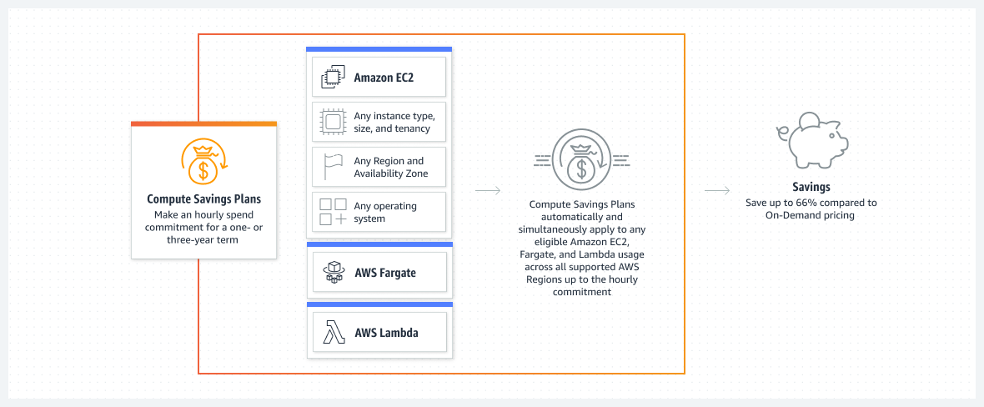
This type of Savings Plan is tailored-fit for computing resources in AWS – not only for EC2 but for Lambda and Fargate as well.
Hence, the correct answer is: Compute Savings Plans.
Dedicated Hosts is incorrect because this is just an offering that allows the user to buy a physical server hosted in the AWS cloud. These physical servers are expensive and are only considered practical for regulatory compliance purposes. Moreover, you would still have to pay the on-demand cost of Lambda functions since the Dedicated Hosts option is only applicable for Amazon EC2.
Reserved Instances are incorrect. Although this option offers a discounted price, this only applies to Amazon EC2 instances. You would still pay for the on-demand cost of Lambda functions unless you opt for the Compute Savings Plans.
Spot instances are incorrect. Just like the previous option, this offering only applies to Amazon EC2 instances. Although Spot instances offer the most cost-savings for up to 90%, these do not apply to Lambda functions. A better option is to use the Compute Savings Plans option.

References:
https://aws.amazon.com/savingsplans/compute-pricing
https://docs.aws.amazon.com/savingsplans/latest/userguide/what-is-savings-plans.html

Check out this Amazon EC2 Cheat Sheet:
https://tutorialsdojo.com/amazon-elastic-compute-cloud-amazon-ec2/

53. QUESTION
Category: CCP – Cloud Technology and Services
Which of the following AWS well-architected pillars discusses the use of the right computing resources to meet demand levels even as the demand changes and technologies evolve?
- Cost optimization
- Operational Excellence
- Performance Efficiency (Correct)
- Reliability

The Well-Architected Framework has been developed to help cloud architects build secure, high-performing, resilient, and efficient infrastructure for their applications. This is based on six pillars namely:
1. Operational Excellence
2. Security
3. Reliability
4. Performance Efficiency
5. Cost Optimization
6. Sustainability

The performance efficiency pillar focuses on using IT and computing resources efficiently. It focuses on the ability to use computing resources efficiently to meet system requirements and to maintain that efficiency as demand changes and technologies evolve.
Hence, the correct answer is: Performance efficiency.
Operational Excellence is incorrect because this pillar focuses on running and monitoring systems to deliver business value and continually improving processes and procedures.
Reliability is incorrect because this pillar focuses on the ability to prevent and quickly recover from failures to meet business and customer demand.
Cost optimization is incorrect because this pillar focuses on avoiding un-needed costs by choosing the right services for the job and by right-sizing them.

References:
https://wa.aws.amazon.com/wat.pillars.wa-pillars.en.html
https://docs.aws.amazon.com/wellarchitected/latest/framework/welcome.html

AWS Well-Architected Framework – Six Pillars Cheat Sheet:
https://tutorialsdojo.com/aws-well-architected-framework-five-pillars

54. QUESTION
Category: CCP – Billing, Pricing and Support
Which type of EC2 instance is the most suitable and cost-effective if the customer will be running mission-critical workloads continuously for a whole year?
- On-Demand
- Reserved (Correct)
- Spot
- Dedicated

Reserved Instances provide you with a significant discount compared to On-Demand Instance pricing. RIs can provide a capacity reservation, offering additional confidence in your ability to launch the number of instances you have reserved when you need them. You can purchase a Reserved Instance for a one-year or three-year commitment, with the three-year commitment offering a bigger discount.
With Reserved Instances (RIs), you can choose the type that best fits your application needs such as Standard RIs, Convertible RIs, and Scheduled RIs.
Reserved Instances are recommended for:
– Applications with steady state usage
– Applications that may require reserved capacity
– Customers that can commit to using EC2 over a 1 or 3 year term to reduce their total computing costs

Hence, the correct answer is Reserved Instances.
Both On-Demand and Dedicated Instance Types are incorrect since they are more expensive than Reserved Instances if billed over a whole year or longer.
Spot Instance is incorrect since this is not optimal for servers that need to be continuously running.

References:
https://aws.amazon.com/ec2/pricing/reserved-instances/
https://docs.aws.amazon.com/AWSEC2/latest/UserGuide/ec2-reserved-instances.html

Check out this Amazon EC2 Cheat Sheet:
https://tutorialsdojo.com/amazon-elastic-compute-cloud-amazon-ec2/

55. QUESTION
Category: CCP – Billing, Pricing and Support
How can your RDS production instances be more cost-effective when they will be used for a long period of time?
- You can stop your RDS instances when idle to prevent AWS from charging you during this time
- You can easily backup, terminate, and restore RDS instances when you need them
- You can request reserved instances to get discounts on your instance costs (Correct)
- AWS does not charge you when your RDS is idle

Amazon RDS Reserved Instances give you the option to reserve a DB instance for a one or three-year term and in turn receive a significant discount compared to the On-Demand Instance pricing for the DB instance.
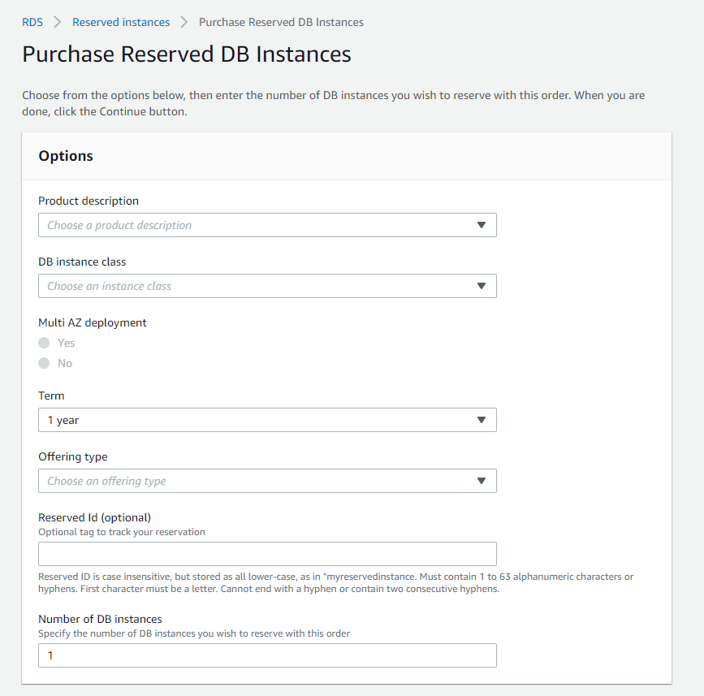
You can choose between three payment options when you purchase a Reserved Instance. With the All Upfront option, you pay for the entire Reserved Instance with one upfront payment. This option provides you with the largest discount compared to On-Demand Instance pricing. With the Partial Upfront option, you make a low upfront payment and are then charged a discounted hourly rate for the instance for the duration of the Reserved Instance term. The No Upfront option does not require any upfront payment and provides a discounted hourly rate for the duration of the term.
All Reserved Instance types are available for RDS Aurora, MySQL, MariaDB, PostgreSQL, Oracle and SQL Server database engines.
Hence, the correct answer is: You can request reserved instances to get discounts on your instance costs.
The option that says: You can stop your RDS instances when idle to prevent AWS from charging you during this time is not the best way to save money as it entails more effort than required to do so. It is still better to opt for reserved instances for your RDS database cluster instead.
The option that says: You can easily backup, terminate, and restore RDS instances when you need them is not the best solution. There is too much effort involved.
The option that says: AWS does not charge you when your RDS is idle is incorrect. Idle time or not, once your RDS instance is running, AWS charges you for it.

References:
https://aws.amazon.com/rds/pricing/
https://aws.amazon.com/rds

Check out this Amazon RDS Cheat Sheet:
https://tutorialsdojo.com/amazon-relational-database-service-amazon-rds/

56. QUESTION
Category: CCP – Cloud Technology and Services
You are planning to deploy a video streaming application with frequently accessed, throughput-intensive workloads to your EC2 instance which requires fast, consistent throughput. What EBS volume type should you use to maximize performance as well as cost?
- Throughput Optimized HDD (Correct)
- Cold HDD
- General Purpose SSD
- Provisioned IOPS SSD

In the exam, always consider the difference between SSD and HDD as shown in the table below. This will allow you to easily eliminate specific EBS-types in the options which are not SSD or not HDD, depending on whether the question asks for a storage type that has small, random I/O operations or large, sequential I/O operations.
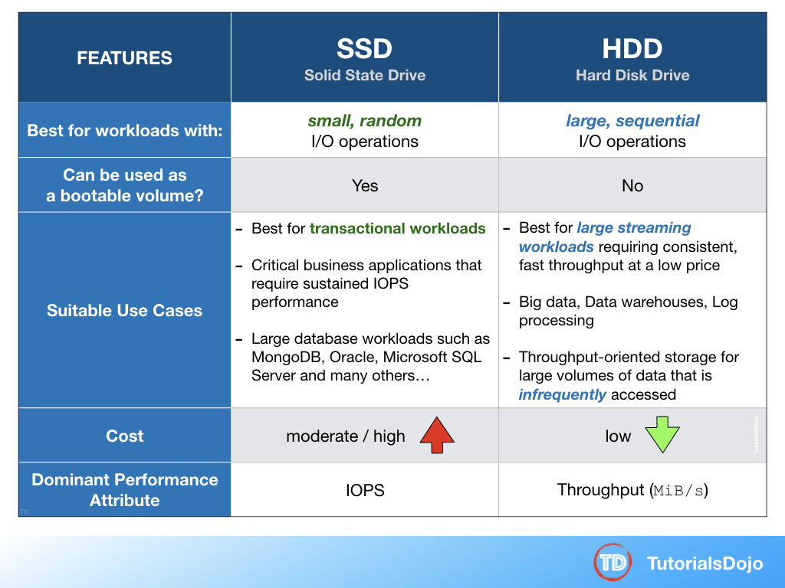
Throughput Optimized HDD (st1) volumes provide low-cost magnetic storage that defines performance in terms of throughput rather than IOPS. This volume type is a good fit for large, sequential workloads such as Amazon EMR, ETL, data warehouses, and log processing. Bootable st1 volumes are not supported. Throughput Optimized HDD (st1) volumes, though similar to Cold HDD (sc1) volumes, are designed to support frequently accessed data.
Hence, the correct answer is: Throughput Optimized HDD.
Provisioned IOPS SSD is incorrect because this is not the most cost-effective EBS type and is primarily used for critical business applications that require sustained IOPS performance.
General Purpose SSD is incorrect because although this volume balances price and performance for a wide variety of workloads, it is not suitable for frequently accessed, throughput-intensive workloads. Throughput Optimized HDD is a more suitable option to use than General Purpose SSD.
Cold HDD is incorrect because although this one provides the lowest cost among all other options, it is much suitable for less frequently accessed workloads.

References:
https://docs.aws.amazon.com/AWSEC2/latest/UserGuide/EBSVolumes.html
https://docs.aws.amazon.com/AWSEC2/latest/UserGuide/EBSVolumeTypes.html#EBSVolumeTypes_st1

Check out this Amazon EBS Cheat Sheet:
https://tutorialsdojo.com/amazon-ebs/

57. QUESTION
Category: CCP – Cloud Technology and Services
You are planning to create point-in-time backups of your Amazon EBS volumes. Which of the following are correct statements? (Select TWO.)
- You can create point-in-time backups through EBS snapshots (Correct)
- Instances will have to be stopped first to start the EBS backup
- EBS backups are stored durably in Amazon S3 (Correct)
- You can take EBS backups by creating Amazon Machine Images (AMIs)
- Backing up the same EBS volume will create a new back up of the whole volume

You can back up the data on your Amazon EBS volumes to Amazon S3 by taking point-in-time snapshots. Snapshots are incremental backups, which means that only the blocks on the device that have changed after your most recent snapshot are saved. This minimizes the time required to create the snapshot and saves on storage costs by not duplicating data. Each snapshot contains all of the information that is needed to restore your data (from the moment when the snapshot was taken) to a new EBS volume.
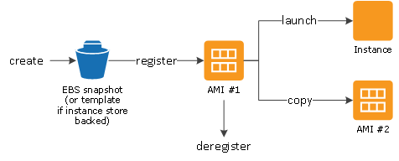
Hence, the correct answer are:
– You can create point-in-time backups through EBS snapshots
– EBS backups are stored durably in Amazon S3
The option that says: You can take EBS backups by creating Amazon Machine Images (AMIs) is incorrect because EBS backup volumes are not called AMIs. An Amazon Machine Image (AMI) is a backup of an EC2 instance along with all of its EBS volumes. Since only a single volume needs to be backed up, you should create EBS Snapshots instead.
The option that says: Backing up the same EBS volume will create a new back up of the whole volume is incorrect because EBS Snapshots are incremental, which means that only the latest changes are backed up when you run the backup process. It does not back up the whole volume again.
The option that says: Instances will have to be stopped first to start the EBS backup is incorrect because you can actually run the EBS backup while the EC2 instance is running. This may cause some deterioration in EC2 performance, but it should not have a noticeable effect.

References:
https://docs.aws.amazon.com/AWSEC2/latest/UserGuide/EBSSnapshots.html
https://docs.aws.amazon.com/AWSEC2/latest/UserGuide/Storage.html

Check out this Amazon EBS Cheat Sheet:
https://tutorialsdojo.com/amazon-ebs/

58. QUESTION
Category: CCP – Cloud Technology and Services
Which of the following services allow you to mask downtime of your application by rerouting your traffic to healthy instances? (Select TWO.)
- AWS ELB (Correct)
- VPC Route tables
- AWS App Mesh
- Amazon Route 53 (Correct)
- AWS EC2 Auto Scaling
AWS ELB and Amazon Route 53 help mask downtime by redirecting traffic to your healthy instances and allowing failover to your secondary systems. This is achieved through a combination of different health checks, routing policies, and failover policies.
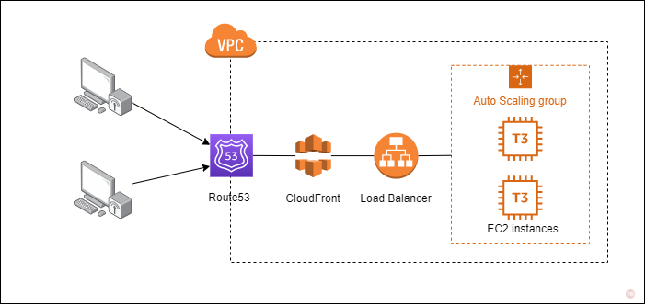
Hence, the correct answers are:
– Amazon Route 53
– AWS ELB
AWS App Mesh is incorrect since this is a service mesh that provides application-level networking to make it easy for your services to communicate with each other across multiple types of compute infrastructure. It does not mask any application downtime automatically.
AWS EC2 Auto Scaling, and VPC Route Tables do not help mask downtime by rerouting traffic to healthy backend servers. EC2 Auto Scaling allows you to automatically scale the number of running instances required to handle your workloads. VPC Route Tables dictate how traffic flows inside your VPC.

References:
https://aws.amazon.com/elasticloadbalancing/
https://aws.amazon.com/route53/

Check out these Tutorials Dojo Cheat Sheets:
https://tutorialsdojo.com/aws-elastic-load-balancing-elb/
https://tutorialsdojo.com/amazon-route-53/
https://youtu.be/UBl5dw59DO8
https://youtu.be/Su308t19ubY

59. QUESTION
Category: CCP – Cloud Concepts
Which of the following will allow users to trade upfront infrastructure costs for flexible operational costs in AWS?
- Use AWS Cost Explorer to analyze service costs and usage and to forecast future expenses.
- Eliminate guessing about users’ infrastructure capacity needs.
- Use AWS Elastic Beanstalk to automate application deployment and management, ensuring seamless scaling of compute resources without incurring additional costs.
- Mitigate upfront infrastructure costs by transitioning from having on-premises data centers to AWS services. (Correct)

Cloud computing is a revolutionary technology that enables users to access computing resources over the internet. It eliminates the need for businesses to invest in costly hardware and software infrastructure. Instead, you can use pay-as-you-go services offered by cloud computing providers like Amazon Web Services (AWS).
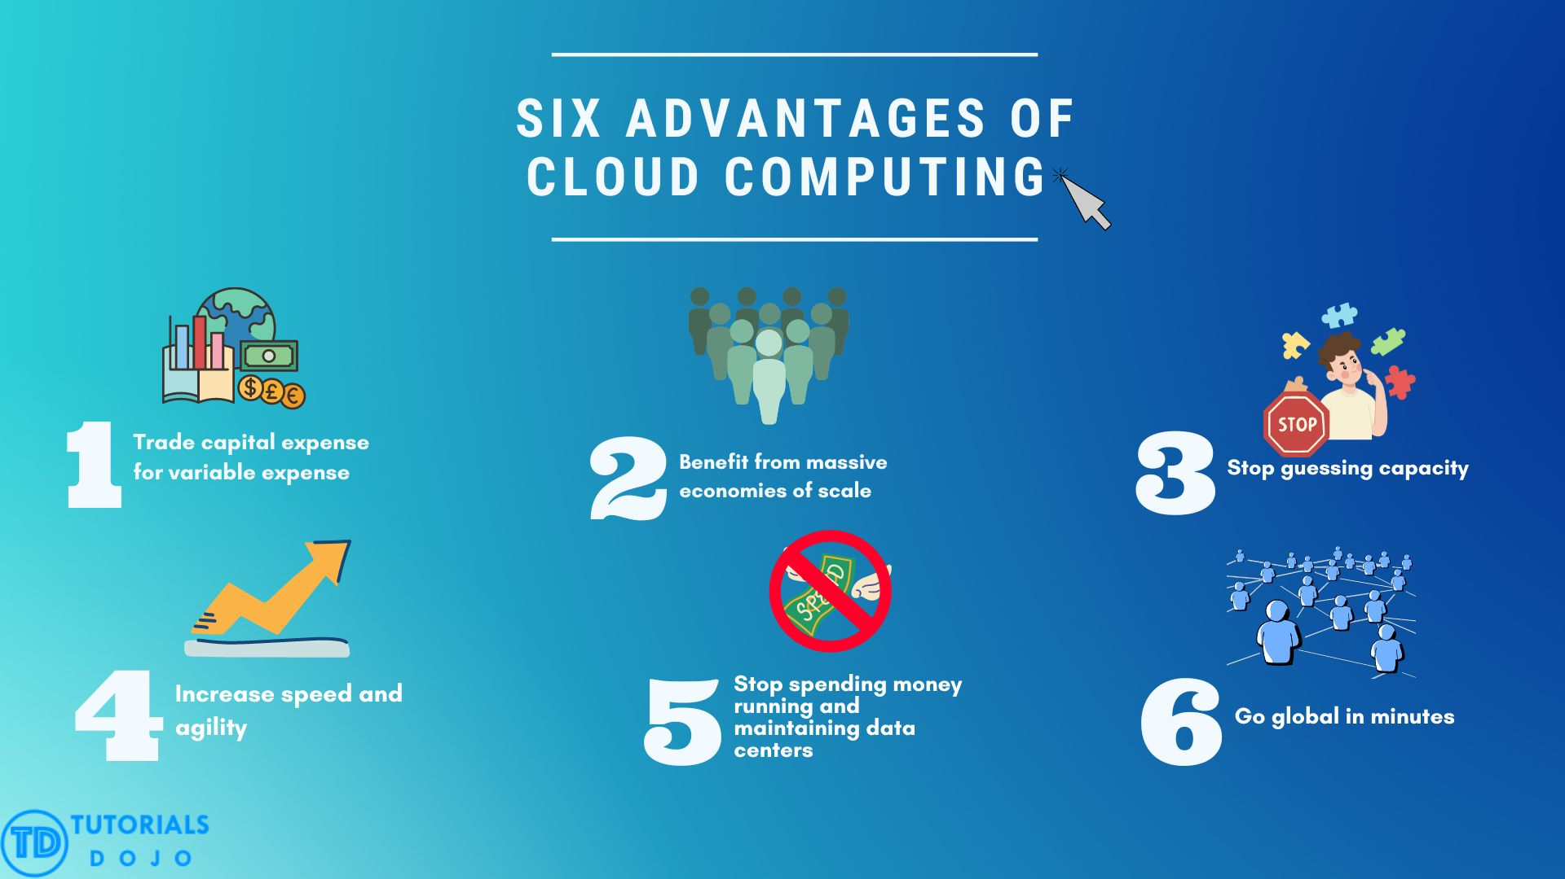
The six significant advantages of cloud computing are:
– Trade fixed expense for variable expense – with cloud computing, businesses can pay only for the number of computing resources they use, which helps them save on upfront infrastructure costs and reduce overall expenses.
– Benefit from massive economies of scale – cloud computing providers like AWS operate massive data centers that house thousands of computing resources. By using these resources, businesses can access more computing power, storage, and networking capabilities than they could ever afford to build on their own.
– Stop guessing capacity – with cloud computing, businesses can quickly scale up or down their computing resources based on their needs, improving flexibility and agility.
– Increase speed and agility – provisioning new computing resources in minutes or seconds with cloud computing allows businesses to respond more to changing business needs.
– Stop spending money running and maintaining data centers – running and maintaining data centers require expensive hardware, software, and personnel. With cloud computing, businesses can outsource these tasks to cloud computing providers like AWS.
– Go global in minutes – cloud computing providers like AWS offer a global network of data centers and edge locations, allowing businesses to deploy their applications closer to customers and improve performance.
Overall, cloud computing is a powerful technology that can provide businesses with significant advantages in cost reduction, scalability, flexibility, agility, and global reach. It is an essential technology for modern businesses in today’s increasingly digital world.
Hence the correct answer is: Mitigate upfront infrastructure costs by transitioning from having on-premises data centers to AWS services.
Use AWS Cost Explorer to analyze service costs and usage and to forecast future expenses is incorrect. AWS Cost Explorer is a tool that lets user visualize, understand, and manage their AWS costs. It focuses on providing insights into users’ costs and usage and forecasting future expenses. However, it does not have the capability to trade upfront infrastructure for operational costs.
Eliminate guessing about users’ infrastructure capacity needs is incorrect because it does not directly address the trade-off between upfront infrastructure costs and flexible operational costs. It only focuses on capacity planning and optimization, which can be achieved using various AWS services.
Use AWS Elastic Beanstalk to automate application deployment and management, ensuring seamless scaling of compute resources without incurring additional costs is incorrect. While it’s true that using AWS Elastic Beanstalk for deploying and scaling applications incurs no direct cost for the service itself. However, the resources running behind the service, such as EC2 instances, RDS databases, and other AWS services, have associated pricing.
References:
https://d1.awsstatic.com/whitepapers/aws-overview.pdf
https://aws.amazon.com/what-is-cloud-computing/

60. QUESTION
Category: CCP – Cloud Technology and Services
A company has a fleet of on-premises servers that require a centralized scalable and durable file storage. It should be able to support massive parallel access. Which of the following is the most appropriate service to use?
- Amazon Redshift
- Amazon S3
- Amazon Elastic File System (EFS) (Correct)
- Amazon Storage Gateway – File Gateway

Amazon Elastic File System (Amazon EFS) provides a simple, scalable, fully managed elastic NFS file system for use with AWS Cloud services and on-premises resources. It is built to scale on-demand to petabytes without disrupting applications, growing and shrinking automatically as you add and remove files, eliminating the need to provision and manage capacity to accommodate growth.
Amazon EFS provides secure access for thousands of connections for Amazon EC2 instances and on-premises servers simultaneously using a traditional file permissions model, file locking capabilities, and hierarchical directory structure via the NFSv4 protocol. Amazon EC2 instances can access your file system across AZs, regions, and VPCs, while on-premises servers can access using AWS Direct Connect or AWS VPN.
Amazon EFS is designed to provide massively parallel shared access to thousands of Amazon EC2 instances, enabling your applications to achieve high levels of aggregate throughput and IOPS with consistently low latencies.
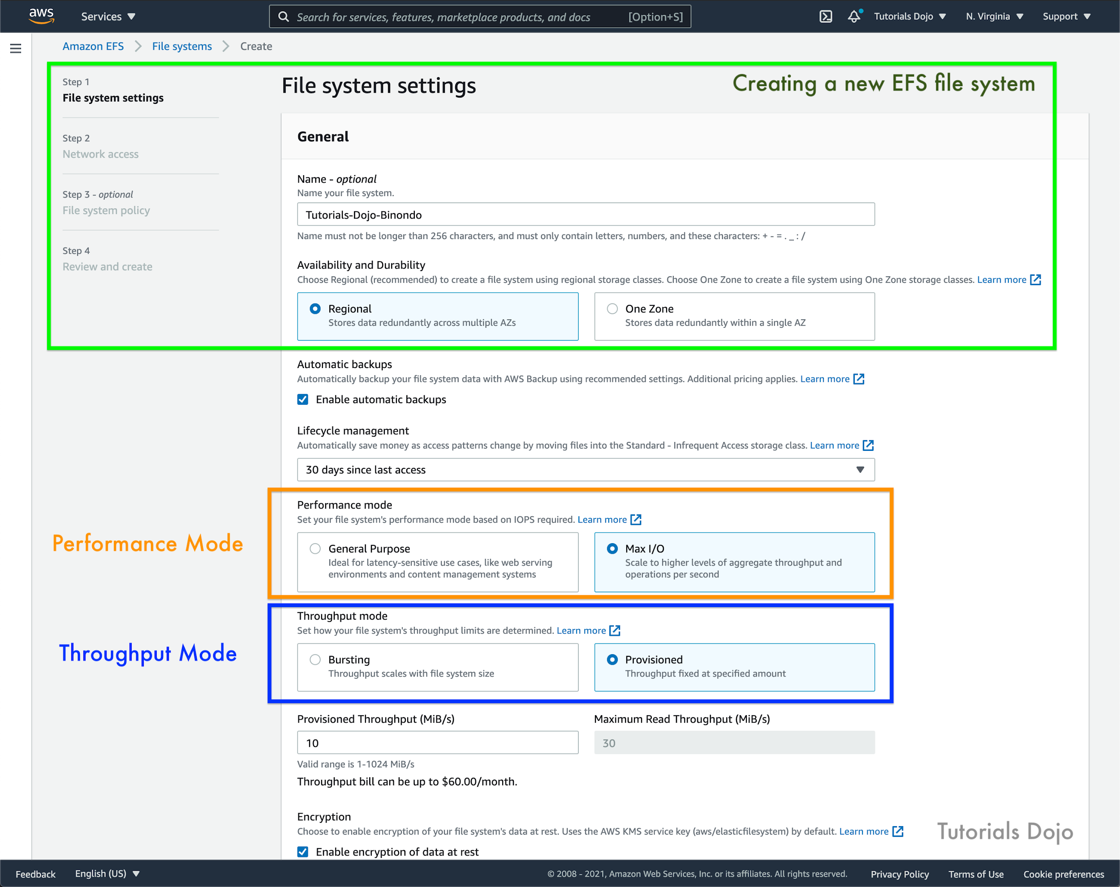
Hence, Amazon Elastic File System (EFS) is the correct answer.
Amazon S3 is incorrect. First, it is meant specifically for object storage, and second, EFS can serve a fleet of EC2 instances better than S3 as file storage.
Amazon Storage Gateway – File Gateway is incorrect because this service simply provides a file interface into Amazon Simple Storage Service (Amazon S3) and is a combination of storage service and a virtual software appliance. This service is meant for local software hosted on the on-premises data center which requires connection to S3. It is not meant to serve a fleet of EC2 instances.
Amazon Redshift is incorrect because this is a data warehousing service offered by AWS. It cannot be used for file storage.

References:
https://aws.amazon.com/efs/
https://docs.aws.amazon.com/efs/latest/ug/whatisefs.html
Amazon Elastic File System – Scalable, Elastic, Cloud-Native File System for Linux

Check out these Tutorials Dojo Cheat Sheets:
https://tutorialsdojo.com/amazon-efs/
https://tutorialsdojo.com/amazon-s3-vs-ebs-vs-efs/

61. QUESTION
Category: CCP – Cloud Technology and Services
You have a large number of log files that will be archived in AWS for a long time and should have a retrieval time of 12 hours or less. Which service is the most cost-effective storage class for this purpose?
- Amazon EBS Cold HDD
- Amazon S3 Glacier Instant Retrieval
- Amazon S3 Standard-IA
- Amazon S3 Glacier Deep Archive (Correct)

Amazon S3 Glacier Deep Archive is Amazon S3’s lowest-cost storage class and supports long-term retention and digital preservation for data that may be accessed once or twice in a year. It is designed for customers — particularly those in highly-regulated industries, such as the Financial Services, Healthcare, and Public Sectors — that retain data sets for 7-10 years or longer to meet regulatory compliance requirements.
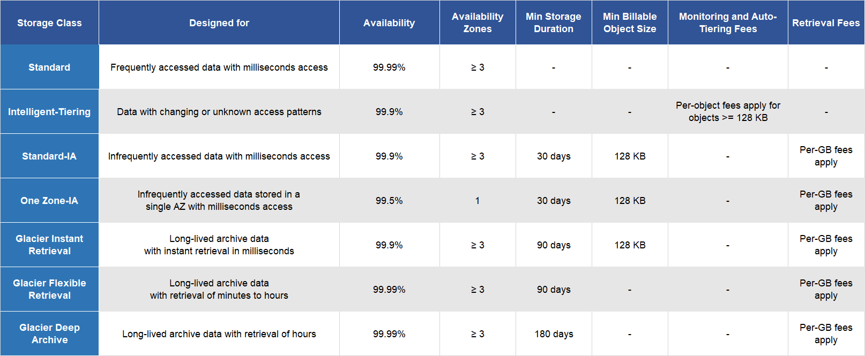
S3 Glacier Deep Archive can also be used for backup and disaster recovery use cases, and is a cost-effective and easy-to-manage alternative to magnetic tape systems, whether they are on-premises libraries or off-premises services. S3 Glacier Deep Archive complements Amazon S3 Glacier, which is ideal for archives where data is regularly retrieved and some of the data may be needed in minutes.
All objects stored in S3 Glacier Deep Archive are replicated and stored across at least three geographically-dispersed Availability Zones, protected by 99.999999999% of durability, and can be restored within 12 hours.
Hence, the correct answer is: Amazon S3 Glacier Deep Archive.
Amazon S3 Standard-IA is incorrect because this costs more than Glacier and Glacier Deep Archive. This storage type takes into consideration that you will still need to retrieve your objects in a timely manner, although infrequently.
Amazon S3 Glacier Instant Retrieval is incorrect because it is already mentioned in the scenario that the retrieval option should be within 12 hours and thus, Glacier Deep Archive can provide a more cost-effective option than the Glacier Instant Retrieval class including the capability to retrieve the data within the mentioned timeframe.
Amazon EBS Cold HDD is incorrect because this is not the best nor the cheapest choice for archival. You use Cold HDD if you have infrequent workloads that require consistent throughput. Also, EBS volumes need to be used along with EC2 instances for you to have access to the stored files.

References:
https://aws.amazon.com/s3/storage-classes/glacier/
https://aws.amazon.com/s3/storage-classes
https://docs.aws.amazon.com/prescriptive-guidance/latest/backup-recovery/amazon-s3-glacier.html

Check out these Amazon S3 and S3 Glacier Cheat Sheets:
https://tutorialsdojo.com/amazon-s3/
https://tutorialsdojo.com/amazon-glacier/

Amazon S3 vs Amazon S3 Glacier Comparison:
https://tutorialsdojo.com/amazon-s3-vs-glacier/

62. QUESTION
Category: CCP – Security and Compliance
Which service in AWS protects your resources from common DDoS attacks in a proactive manner?
- Amazon Inspector
- Security groups
- AWS WAF
- AWS Shield (Correct)

AWS Shield is a managed Distributed Denial of Service (DDoS) protection service that safeguards applications running on AWS. AWS Shield provides always-on detection and automatic inline mitigations that minimize application downtime and latency, so there is no need to engage AWS Support to benefit from DDoS protection. There are two tiers of AWS Shield – Standard and Advanced.
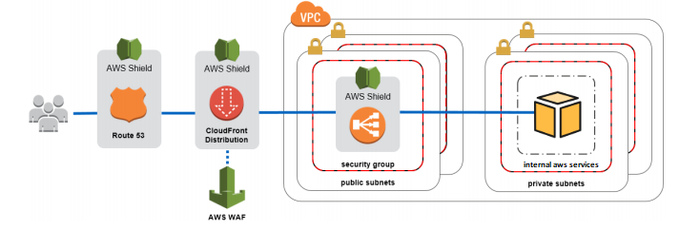
All AWS customers benefit from the automatic protections of AWS Shield Standard, at no additional charge. AWS Shield Standard defends against the most common, frequently occurring network and transport layer DDoS attacks that target your website or applications. When you use AWS Shield Standard with Amazon CloudFront and Amazon Route 53, you receive comprehensive availability protection against all known infrastructure (Layer 3 and 4) attacks.
Hence, the correct answer is: AWS Shield.
Amazon Inspector is incorrect as this is just an automated security assessment service that helps improve the security and compliance of applications deployed on AWS. Amazon Inspector automatically assesses applications for exposure, vulnerabilities, and deviations from best practices. After performing an assessment, Amazon Inspector produces a detailed list of security findings prioritized by level of severity.
Security groups is incorrect. Although it protects your instance-level traffic by acting as virtual firewalls for your instances, it is not enough to protect you from DDoS attacks. It controls which inbound and outbound traffic is allowed via security group rules. The traffic controls are, however, added via whitelisting, so you have a reactive answer to DDoS. AWS Shield offers a proactive solution since you do not need to specify which types of traffic are considered malicious.
AWS WAF is incorrect since this is simply a web application firewall that helps protect your web applications from common web exploits such as XSS and SQL injection. You use AWS WAF to create custom rules that block common attack patterns and rules that are designed for your specific application.
References:
https://aws.amazon.com/shield/
https://aws.amazon.com/shield/faqs/

Check out this AWS Shield Cheat Sheet:
https://tutorialsdojo.com/aws-shield/
AWS Security Services Overview – WAF, Shield, CloudHSM, KMS:
https://youtu.be/-1S-RdeAmMo

63. QUESTION
Category: CCP – Security and Compliance
A customer needs to identify the IAM user who terminated their production EC2 instance in AWS. Which service should they use in this situation?
- Amazon AppStream 2.0
- AWS Systems Manager
- Amazon CloudWatch
- AWS CloudTrail (Correct)

AWS CloudTrail is a service that enables governance, compliance, operational auditing, and risk auditing of your AWS account. With CloudTrail, you can log, continuously monitor, and retain account activity related to actions across your AWS infrastructure. CloudTrail provides the event history of your AWS account activity, including actions taken through the AWS Management Console, AWS SDKs, command-line tools, and other AWS services. This event history simplifies security analysis, resource change tracking, and troubleshooting.

With AWS CloudTrail, you can simplify your compliance audits by automatically recording and storing event logs for actions made within your AWS account. Integration with Amazon CloudWatch Logs provides a convenient way to search through log data, identify out-of-compliance events, accelerate incident investigations, and expedite responses to auditor requests.
It also increases visibility into your user and resource activity by recording AWS Management Console actions and API calls. You can identify which users and accounts called AWS, the source IP address from which the calls were made, and when the calls occurred.
Hence, the correct answer is: AWS CloudTrail.
Amazon CloudWatch is incorrect because this service is primarily used to collect monitoring and operational data in the form of logs, metrics, and events, providing you with a unified view of AWS resources, applications, and services that run on AWS and on-premises servers.
Amazon AppStream 2.0 is incorrect because this is a fully managed application streaming service that you can use to centrally manage your desktop applications. Also, this service cannot identify the user that terminated the EC2 instance.
AWS Systems Manager is incorrect because this is a unified user interface where you can view operational data from multiple AWS services and allows you to automate operational tasks across your AWS resources.

References:
https://aws.amazon.com/cloudtrail/
https://aws.amazon.com/cloudtrail/faqs/

64. QUESTION
Category: CCP – Security and Compliance
Which of the following AWS services are used to secure your VPC network? (Select TWO.)
- Network ACL (Correct)
- Security group (Correct)
- Application load balancer
- CloudFront
- IAM

A security group acts as a virtual firewall for your instance to control inbound and outbound traffic. Security groups act at the instance level, not the subnet level. Therefore, each instance in a subnet in your VPC could be assigned to a different set of security groups. For each security group, you add rules that control the inbound traffic to instances, and a separate set of rules that control the outbound traffic.
A network access control list (ACL) is an optional layer of security for your VPC that acts as a firewall for controlling traffic in and out of one or more subnets. You might set up network ACLs with rules similar to your security groups in order to add an additional layer of security to your VPC.

Hence, the correct answers are Network ACL and Security Group.
The other options (Application load balancers, Amazon CloudFront and AWS IAM) are incorrect because these services do not safeguard your VPC traffic. They are different products that serve different functions.

References:
https://docs.aws.amazon.com/vpc/latest/userguide/VPC_Security.html
https://docs.aws.amazon.com/vpc/latest/userguide/VPC_SecurityGroups.html
https://docs.aws.amazon.com/vpc/latest/userguide/vpc-network-acls.html

Check out this Amazon VPC Cheat Sheet:
https://tutorialsdojo.com/amazon-vpc/

65. QUESTION
Category: CCP – Billing, Pricing and Support
A startup plans to build a data lake using Amazon S3 as the primary storage platform. Which of the following options would incur costs? (Select TWO.)
- Egress data to the internet. (Correct)
- Ingress data from the internet.
- Setting up S3 lifecycle policies. (Correct)
- Creating S3 bucket policies.
- Modifying S3 event notifications.

Amazon S3 provides an optimal foundation for a data lake because of its virtually unlimited scalability and high durability. You can seamlessly and non-disruptively increase storage from gigabytes to petabytes of content, paying only for what you use. Amazon S3 is designed to provide 99.999999999% durability. It has scalable performance, ease-of-use features, native encryption, and access control capabilities. Amazon S3 integrates with a broad portfolio of AWS and third-party ISV tools for data ingestion, data processing, and data security.
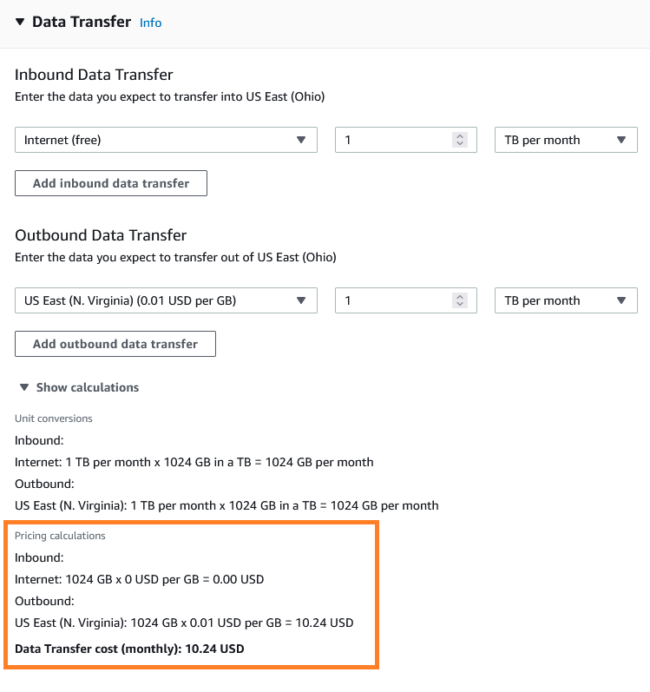
Egress data to the internet – also known as “data transfer out from Amazon S3 to the internet”. When you transfer data to the internet, you are charged for the storage size per month and the region that the object will be transferred to.
Setting up S3 lifecycle policies – when you configure this in your S3 bucket, you will specify where the object will be moved to other storage classes. This means that you’ll pay for storage pricing, and there are per-request ingest charges when using PUT, COPY, or lifecycle rules to move data into any S3 storage class.
Hence, the correct answers are:
– Egress data to the internet.
– Setting up S3 lifecycle policies.
The option that says: Modifying S3 event notifications is incorrect because you are only charged for running an AWS Lambda function or using Amazon SNS or Amazon SQS to deliver event notifications. There are no charges associated with making changes to your S3 event notifications.
The option that says: Ingress data from the internet is incorrect because there are no charges for data transfer “in” to Amazon S3 from the internet. You only pay for data transfer “out” from Amazon S3 to the internet.
The option that says: Creating S3 bucket policies is incorrect because creating S3 bucket policies is free of charge. S3 bucket policies define who can access objects stored in an S3 bucket, where they can access them, and what actions they can perform.

References:
https://docs.aws.amazon.com/whitepapers/latest/building-data-lakes/amazon-s3-data-lake-storage-platform.html
https://aws.amazon.com/s3/pricing/
https://aws.amazon.com/s3/faqs/

Check out this Amazon S3 Cheat Sheet:
https://tutorialsdojo.com/aws-cheat-sheet-amazon-s3/

